**Reporting Strategies for Head and Neck Cancer**

Basics of MR imaging in head and neck: Importance of correct protocol and role of various MR sequences :

T1WI:

1. What it depicts well: Best depicts fat.
   1. Useful to define margins and extent of the tumour.
   2. Helps to define bone involvement.
2. Pre- contrast FS sequence is of NO use (due to poor contrast)- therefore acquire it ONLY if the tumour is T1 hyperintense to start with.
3. T1WI should be reviewed in at two planes.
4. T1 axial images are the workhorse sequence for the head and neck cancer-:
   1. Provide general anatomic overview
   2. Highlight anatomic distortions and asymmetries which helps to localise the tumours
5. Sagittal T1-weighted images:
   1. Best for midline structures such as the clivus and cervical spine
   2. best suited for nasopharynx, base of the tongue, and posterior pharynx.
6. Coronal T1-weighted images :
   1. Best suited for Orbits, sinonasal cavity, and skull base foramina.
7. Axial, sagittal, and coronal T1-weighted images may be obtained as individual 2D acquisitions or as reconstructions from a single 3D acquisition. Three-dimensional acquisition performed using a spin-echo method offers time savings, thinner slices, and black-blood images that may aide assessment for vessel compromise.

T2WI:

1. Usually prefer T2WI with Fat sat(using Dixon or STIR technique).Consider T2WI without FS is there is dental amalgam as this can cause artifacts.
2. Critical sequence t identify the primary tumour.
3. T2WI canal also help in characterisation of pathology of the tumour -:
   1. SCC-: intermediate signal
   2. Chordoma and chondrosarcoma: hyperintense
   3. Lymphoma -: hypointense
4. T2WI also helps in looking for CSF filled skull base areas such as Meckel’s cave- the CSF signal will be lost if the tumours infiltrates these structures.
5. T2WI helps in differentiating tumour recurrence versus post treatment changes-: the post treatment changes are hyperintense due to oedema, while the tumour recurrence has signal intensity similar to the primary tumour.
6. Post contrast imaging- preferred T1WI with fat sat. Consider contrast enhanced acquisition without fat sat if there are too many artefacts. At least two planes needed- axial and coronal. Sagittal useful for midline structure. Post contrast 3D can also be used thought getting good fat sat with 3D sequence is difficult.

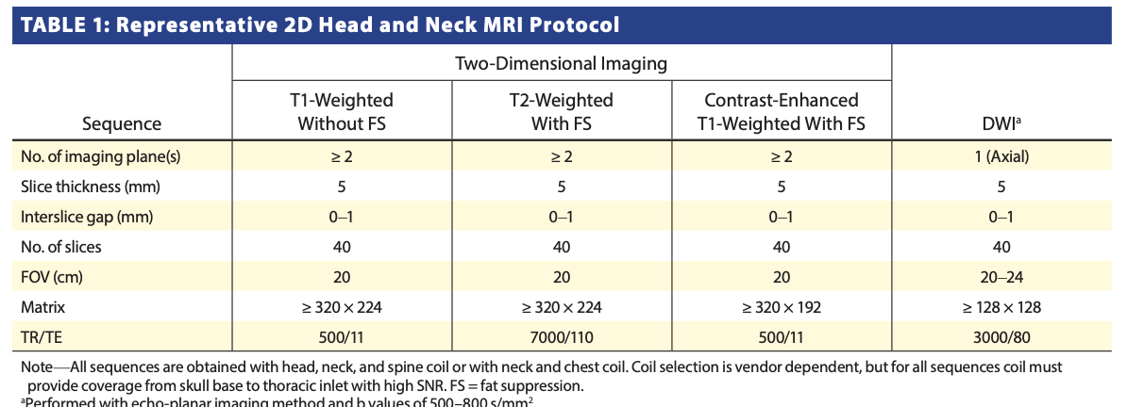

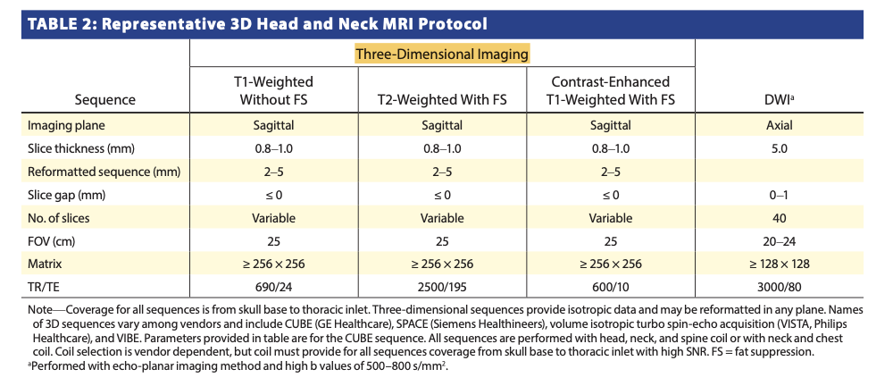

Optional sequences:

1. DWI: Useful in:
   1. Post treatment changes v/s tumour recurrence.
   2. Can make primary tumour or involved node more conspicuous due to background reduction in signal intensity in DWI. (acquisition time is 1-2 minutes). Routine echoplanar DWI is suspectable to artifact from air-bone interphases. Non echoplanar techniques (such as PROPELLAR in GE and HASTE in Siemens) are helpful in mitigating these artifacts but they take very long time for acquisition due to large are involved in head and neck (unlike mastoid , where only a small area is scanned).
2. Contrast enhanced perfusion imaging: Can be useful to delineate pirmry tumour and asses for recurrence. But need post processing. So not ideal.
3. ASL-: arterial spin labelling helps to delineate tumour as hyper vascular area without need for contrast administration- a useful technique which can be done routinely if the centre has this facility.

Follow up /surveillance of head and neck cancers:

1. Consensus- perform on post treatment baseline imaging at 3 months following treatment.
2. 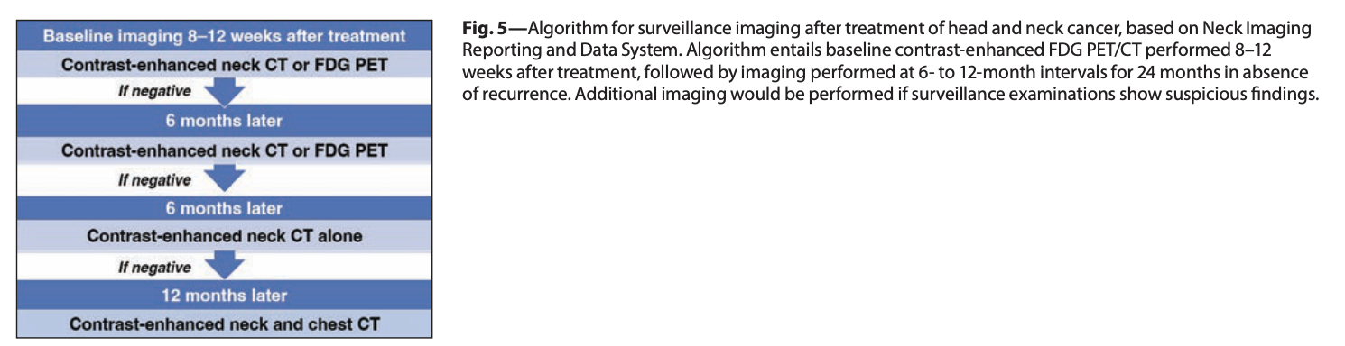

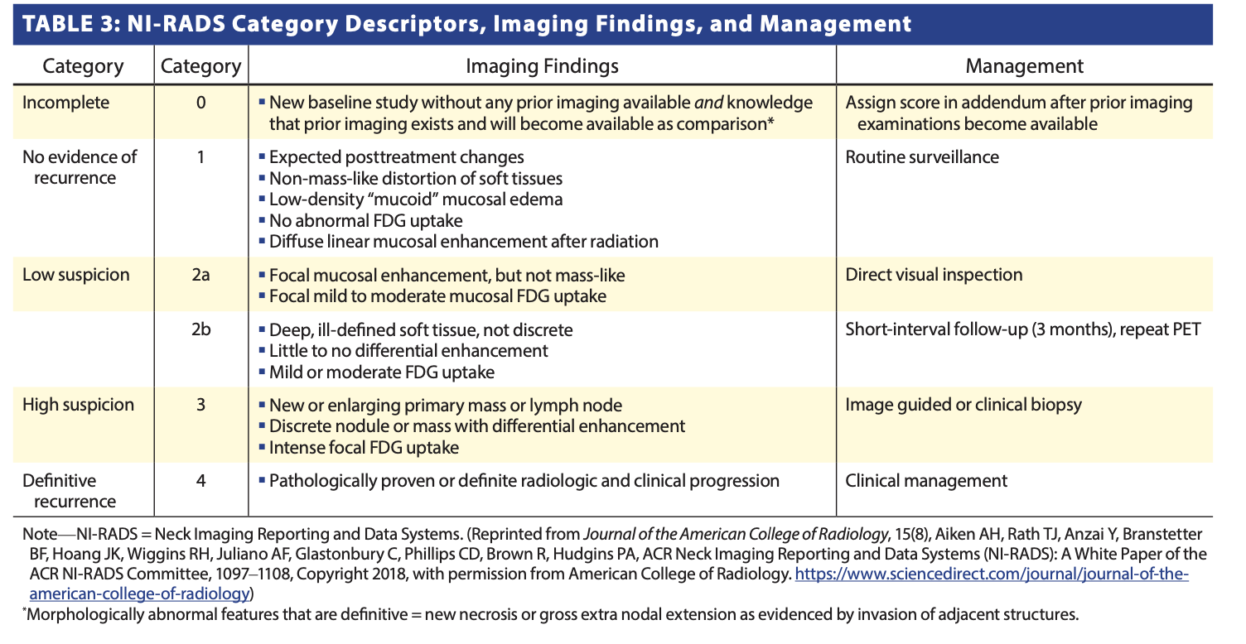

**How Does Clinical and Immunohistochemical Information Influence the Imaging Evaluation of Patients With NCUP?**

NCUP, representing 3% of new cases of head and neck cancer [40], is defined as the clinical presentation of metastatic cervical nodal disease without an obvious primary tumor by both clinical examination and initial imaging evaluation. This designation is fre- quently transient, as subsequent workup usually leads to the iden- tification of a cutaneous or mucosal head and neck primary tumor. NCUP typically involves level I, II, III, or VA lymph nodes. In compar- ison, isolated supraclavicular lymphadenopathy (i.e., levels IV and VB) usually arises from primary disease in the thyroid gland or an infraclavicular organ. Some patients with NCUP are found to have lymphoma or other noncarcinoma metastatic lesions [41].

***Clinical and Imaging Evaluation***

The HPV or EBV status of the FNA sample acquired from the pathologic lymph node provides critical initial information, as more than 90% of cases of NCUP are HPV related [41, 42].

1. HPV-re- lated NCUP usually has a primary tumor located within the-:
   1. Oropharynx-:
      1. 43% found within the palatine tonsils
      2. 39% in the lingual tonsils or base of the tongue [43].
2. EBV-related nasopharyngeal carcinoma. EBV-related nasopharyngeal carcinoma is diagnosed by EBV-related RNA testing by in situ hybridization; testing should be performed when *p16* status is negative [44]. Primary tumor sites in patients with EBV-positive metastatic cervical lymphadenopathy include -:
   * 1. nasopharynx (51.7%)- level i/II nodes.
     2. salivary gland (24.5%)- *mostly level I and Level II nodes.*
     3. lung (7.8%)- level IV node.
     4. liver (0.4%) -*If lung and liver primary- then usually nodal metastasis are* level IV lymph nodes.
3. Although *p16*-positive status is highly correlated with HPV infection in HNSCC, *p16* expression is not limited to HPV-positive oropharyngeal tumors, such that *p16* is an imperfect surrogate marker for HPV-related head and neck neoplasia. A *p16*-positive neck mass unrelated to HPV may arise from a –
   1. Cutaneous primary tumor- If an unknown cutaneous pri- mary site is suspected, then DNA damage evaluation can be per- formed on the nodal FNA sample. Next-generation sequencing can identify ultraviolet light DNA damage signatures consisting of a higher number of C-to-T substitution–type somatic muta- tions that are specific for skin cancer
   2. pulmonary primary tumor. This differentiation requires additional testing to directly evaluate for viral genetic material to support an oropharyngeal versus nonoropharyngeal site of origin. In such patients, chest CT or whole-body FDG PET/CT is useful to identify a lung primary, especially in the setting of a metastatic lymph node in the low neck (levels IV and V)
4. Established guidelines for selecting imaging modalities to identify an occult primary site are lacking, and this assessment is currently accomplished by any combination of contrast-en- hanced CT, MRI, or FDG PET.
5. Occult HPV-related primary oropha- ryngeal SCC may be extremely small or located within the tonsillar crypts, thus being impossible to identify on direct visual inspec- tion or on palpation. However, such tumors may be visible on im- aging even when not apparent on clinical examination. Imaging findings include subtle asymmetry in size, irregularity (especial- ly along the deep margins of the tonsils, adjacent glossotonsillar sulcus, and base of tongue), or variability in internal architecture (e.g., different signal intensity, attenuation, or enhancement vs normal tissue). Imaging interpretation requires careful evaluation of the shape, margins, and enhancement pattern of the lingual and palatine tonsils. On MRI, the lesion may only be identified on DWI given background tissue suppression that may increase the conspicuity of cellular primary tumor [48] (Fig. 6). The lesion may also be identified only by contrast-enhanced FDG PET/CT (Fig. 7). Although FDG PET has high sensitivity (73.1%) and NPV (68.9%) for detecting the primary site in NCUP compared with other mo- dalities, it is prone to false positives and false negatives and has limited overall accuracy, especially for small primary tumors
6. Tonsillectomy, in conjunction with direct laryngoscopy under general anesthesia, identifies primary tumors in a substantial per- centage of patients with negative FDG PET [50]. As false-positive results on FDG PET are common after tonsillar manipulation or palpation or when performed after a prior intervention, such im- aging should preferably be performed before tissue sampling. A common source of false-negative results on FDG PET is obscura- tion of small oropharyngeal primary tumors by physiologic up- take in the normal lingual or palatine tonsillar lymphoid tissue; detection of such tumors may require increasing image contrast by narrowing the image window settings [49]. Other common sources of false-negative results on FDG PET include dental hard- ware–related artifacts.
7. ***Staging and Treatment Overview of NCUP*** –The 8th edition of the AJCC staging manual identifies three distinct staging systems for NCUP-:
   1. Those associated with the *p16*-positive or HPV pathway follow the staging system for NCUP of oropharyngeal origin
   2. those associated with the EBV pathway follow the staging system for NCUP of nasopharyngeal origin, and
   3. those with both *p16*-negative and EBV-negative status are staged using the generic N category. -: Key features in such nodal staging systems include the presence of ipsilateral, contralateral, or bilateral lymph nodes; nodal size (with long-axis cutoffs of 3 and 6 cm); and extranodal extension
   4. Treatment of the neck typically includes either upfront sur- gery followed by radiation therapy with or without chemother- apy or upfront definitive radiotherapy with or without chemo- therapy [50]. For patients undergoing upfront neck dissection, a common approach is to concurrently assess for the primary tu- mor by removing the ipsilateral tonsil and performing intraoper- ative frozen section analysis, followed by lingual tonsillectomy if the palatine tonsil yields benign pathologic results. If the primary site is identified, resection is performed in the same setting, often through a transoral robotic approach

**Consensus Statements**

***MRI Protocols for Head and Neck Cancer***

* MRI for the evaluation of head and neck cancer should routinely include T1-weighted imaging with- out FS, T2-weighted imaging with FS, and postcontrast T1-weighted imaging with FS. These sequences should all be reviewed in two or three planes, whether ob- tained through separate multiplanar 2D acquisitions or reconstruction of a single 3D acquisition.
* MRI for the evaluation of head and neck cancer should routinely include T1-weighted imaging with- out FS, T2-weighted imaging with FS, and postcontrast T1-weighted imaging with FS. These sequences should all be reviewed in two or three planes, whether ob- tained through separate multiplanar 2D acquisitions or reconstruction of a single 3D acquisition.

***Surveillance Imaging in Head and Neck Squamous Cell Cancer***

* The available evidence supports routinely acquiring a baseline surveillance imaging examination within the first 6 months after treatment. The most widely accept- ed practice is to perform a contrast-enhanced PET/CT at 8–12 weeks after completion of therapy.

The ACR NI-RADS interpretation approach and reporting templates should be used for surveillance imaging examinations. Use of NI-RADS improves the consistency of reporting and communication, guides clinical management, and contributes to a repository of data to aid in future outcomes-based research examinations. Use of NI-RADS improves the consistency of reporting and communication, guides clinical management, and contributes to a repository of data to aid in future out- comes-based research.

***Imaging in NCUP***

* Imaging evaluation in NCUP must consider *p16* and HPV status (typically positive in oropharyngeal tumors) as well as EBV status (typically positive in nasopharyngeal tumors). These markers guide the radiologist in identification of the primary site. Most cases of NCUP are due to *p16*-positive HPV-associated primary tumors of the oropharynx, thus requiring meticulous evaluation of this region on imaging.
* For cases of NCUP that are both HPV and EBV negative, primary sites involving the skin, mucosal surfaces out- side of the nasopharynx and oropharynx, and infraclavicular organs should be considered.

***Simultaneous PET/MRI in Head and Neck Squamous Cell Cancer***

• The role of simultaneous PET/MRI in head and neck can- cer remains undefined. Studies suggest that PET/MRI may improve assessment of local tumor extent compared with PET/CT. However, large prospective multicenter studies are needed to establish the modality’s value

Carotid space abnormalities

Tumour cause displacement of strucgtures of

|  |  |  |  |
| --- | --- | --- | --- |
| ICA | ECA | IJV | Tumour |
| Splayed posteriorly | Splayed away from ICA | Not relevant | Carotid body tumour |
| Anteriorly and medially |  | *Posteriorly and laterally* | Vagus Schwanoma  (but at infrahyoid location- the IJV is not displaced too much posteriorly but mainly laterally- hence becomes difficult to differentiate from sympathetic nerve system Schwanoma (see below). But in general Vagus nerve Schwanoma will not show much enhancement.  D/D of Vagus nerve Schwanoma will be cervical nerve root Schwanoma- they will also displace both carotid arteries anteriorly and IJV laterally. |
| Anteriorly | Anteriorly | *Anteriorly* | Sympathetic nerve system Schwanomas |
| Encased | Encased | Encased | Parapharyngeal mucosal squamous cell carcinoma and rarely (Shamblin type C) Paragangliomas |
| Posteriorly | Posteriorly | Posteriorly | Ansa Cervicalis Schwanoma (tend to be infra hyoid) |

Summery :

1. **All three displaced anteriorly- SNS Schwanoma**
2. **All three displaced posteriorly- Ansa Cervicalis Schwanoma**
3. **Arteries displaced anteriorly while Jugular vein displaced posteriorly and laterally- Vagus nerve Schwanoma (and cervical nerve root Schwanoma).**
4. **Arteries splayed with postirony displacement of ICA- CBT.**

**Neurogenic tumour are -:**

* **Schwanoma – two types – Antonie A and Antonie B. Have low vascularity.**
* **Neurofibroma- Tend to have areas with target signs- dark centre and bright periphery (in MRI)**

**Extracranial Meningiomas-: 2% of all Meningiomas . Most common location are Sinonasal > middle ear > Temporal bone > PPA > infratemporal. Generally associated with NF2**

**Shamblin Grouping/ classification for grading carotid body tumours -:**

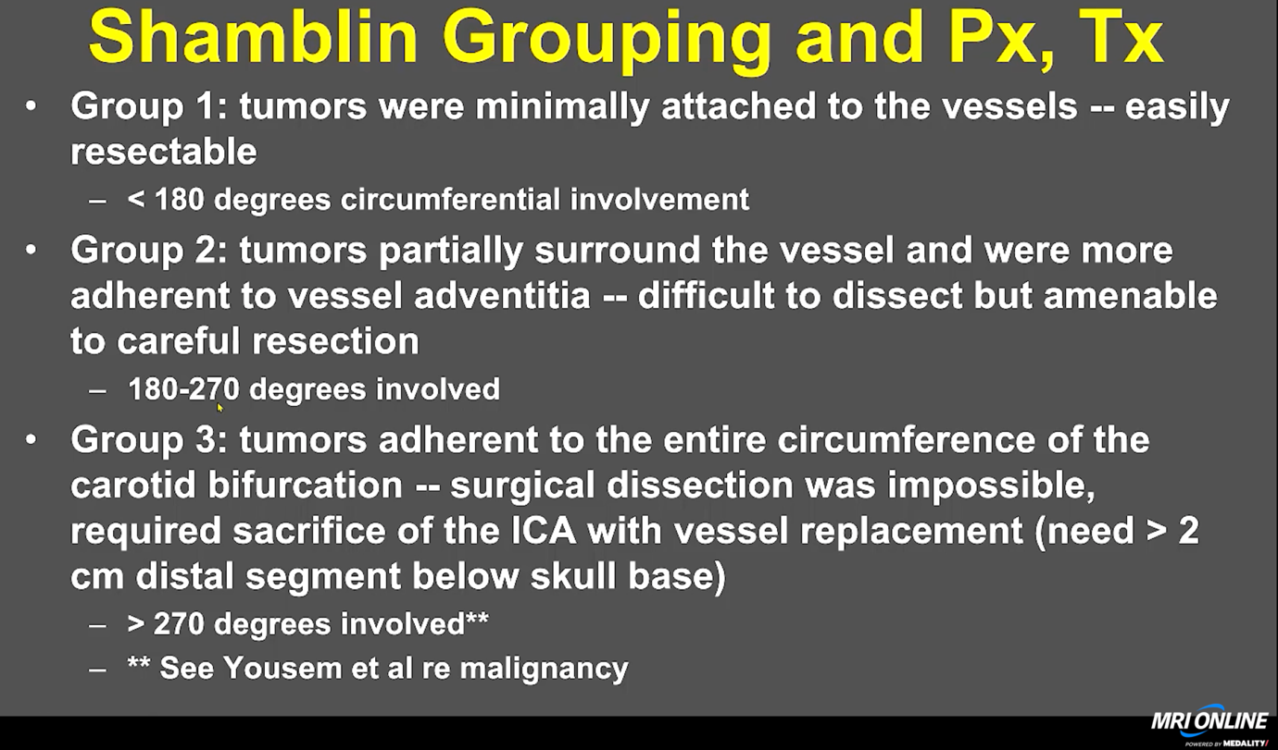

**Vascular salvageability -:**

**270-degree rule-**

**In general malignant tumours which encase a vessel by more than 270 degree, -----are most likely infiltrating that vessel and it will be unlikely to salvage such a vessel during surgery. In case of Carotid artery this usually means in operability of tumour. In such case, the surgeon has two option-:**

**Option 1-: Choose radiotherapy or chemotherapy.**

**Option 2-: Preoperative balloon occlusion challenge- occlude the involved carotid artery preoperatively for some time and see how patient responds. If there is enough collateral flow, then surgeon can proceed to surgery.**

**Shamblin grouping**

**Tumour which have>= 270 degree encasement of Carotid artery and still the artery may be salvageable is true with – Chordoma / adenocarcin9ka and meningioma but never with SqCCa.**

**Beware of glottic and supraglottic carcinoma which sometime spread from posterior aspect with very little laryngeal component and then can invade Carotid sheath and neck structures.**

**Nodal staging :**

**Central v/s lateral and Vertical demarcations (Above Hyoid, v/s below Hyoid) See diagram below -:**

1. **Central -:**
   1. **IA and IB -:**
      1. **IA- submental- mylohyoid**
      2. **IB- Submental – digastric respectively)**
   2. **VI-: Below Hyoid but above Manubrium – paratracheal.**
   3. **VII- below Manubrium- paratracheal.**
2. **Lateral nodes-:** 
   1. **II-Above Hyoid-**
      1. **IIA- Entirely anterior to IJV**
      2. **IIB-; entirely behind the IJV**
   2. **III-: below Hyoid but above Cricoid**
   3. **IV- Between Cricoid and Clavicle**
   4. **V-: Entirely behind the sternocleidomastoid -:**
      1. **VA-: Above cricoid**
      2. **VB- Below Cricoid.**

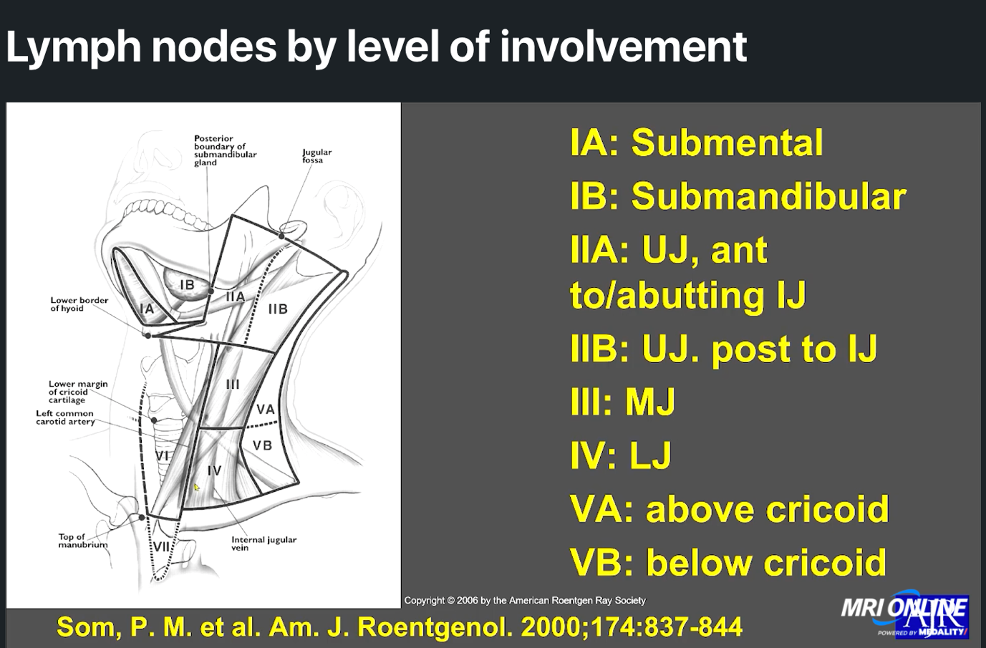

**Rare and unusual diagnosis in carotid space;**

**(VITAMIN C &D)**

* **Normal variant- medial deviation of the carotid artery due to weakness of the fascia.**
* **Mafan’s syndrome**
* **Loeys Deitz syndrome : Aortic aneurysm (same as Marfans) + hypertelorism + bifid uvula and palate**
* **Infection: Lemeirs disease (thrombophlebitis of Jugular vein)**
* **Inflammation of floor of mouth >> extending to submandibular space >> and then to carotid space : Ludwig Angina (may lead to compromise of airway).**
* **Dissection of carotid artery -: Bifils classification of severity of traumatic injury of blood vessels.**
* **Biffl scale/ classifications for traumatic dissection of the blood vessels:** 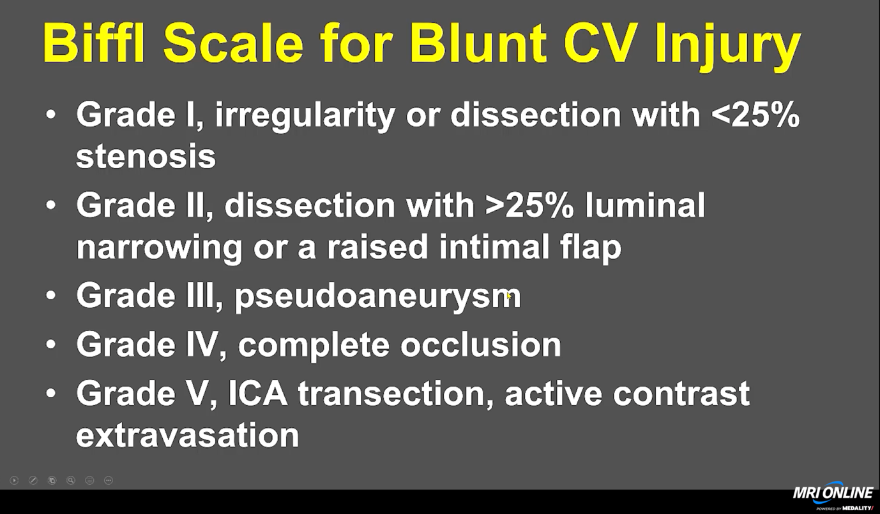
  + 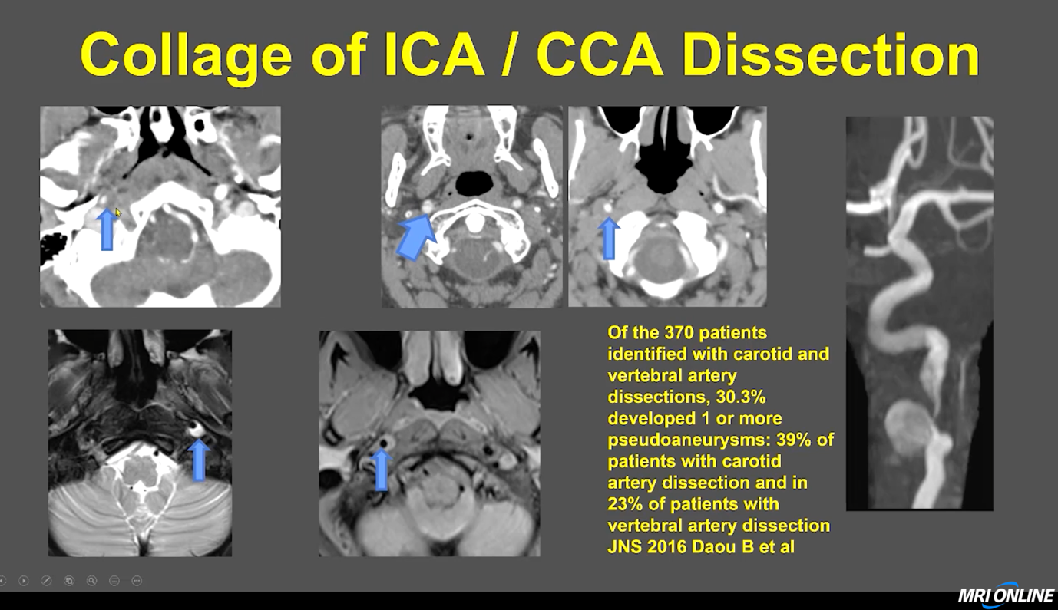
* **Carotid webs- are normal variant- but recently it has been shown that they do increase risk of recurrent stroke in the patient with web and first episode of stroke.**
* **Dissection – can be asymptomatic- the risk of stroke falls to baseline after 1st 2 weeks. So dissection with no symptoms are treated conservatively with antiplatelet drugs for 2 weeks and then the drugs are weaned off. MC dissection in neck is that of vertebral arteries.**
* **Carotiddynia- thickening of wall and narrowing of vessel with inflammatory tissue around the Carotid artery- resolved in 2 weeks after NSAID treatment.**
* **Benign tumours of carotid space : Most tumour of carotid space are benign-: PGN (Glomus Jugulari , glomus vagal, CBT , Glomus Tympanicum0 that GJ growing into middle ear) / Schwanoma / meningioma/ malignancy – 270 degree rule.**

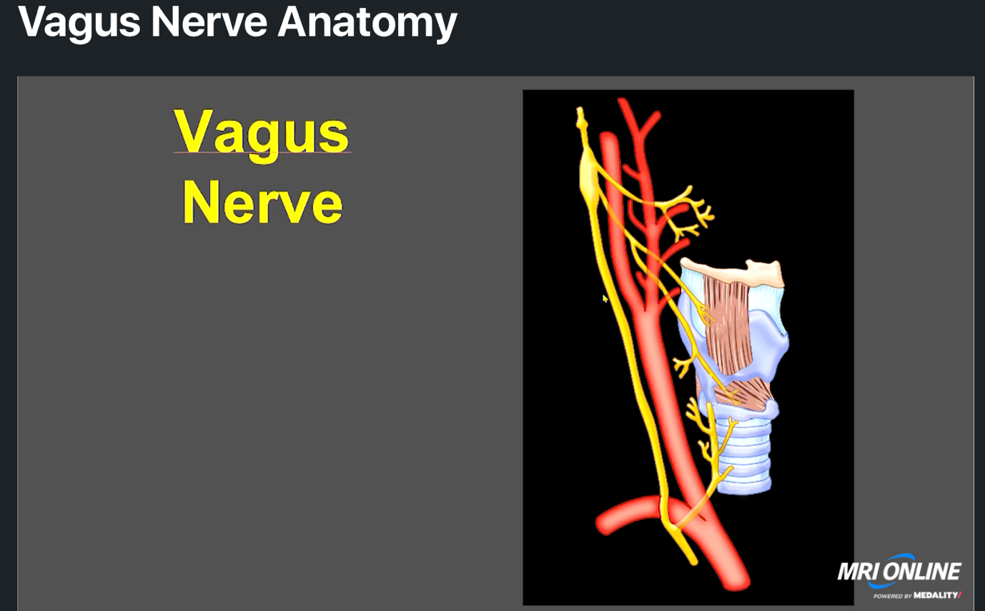

**VAGUS NERVE SCHWANAOM- WILL BE DISPLACING THE IJV POSTERIOR LATERALLY AND CAROTID ARTERIES ANTERIORLY.**

**BUT, THE SYMPATHETIC NERVE TUMOUR WILL DISPLACE BOTH CAROTID ARTERIES AND IJV ANTERIORLY.**

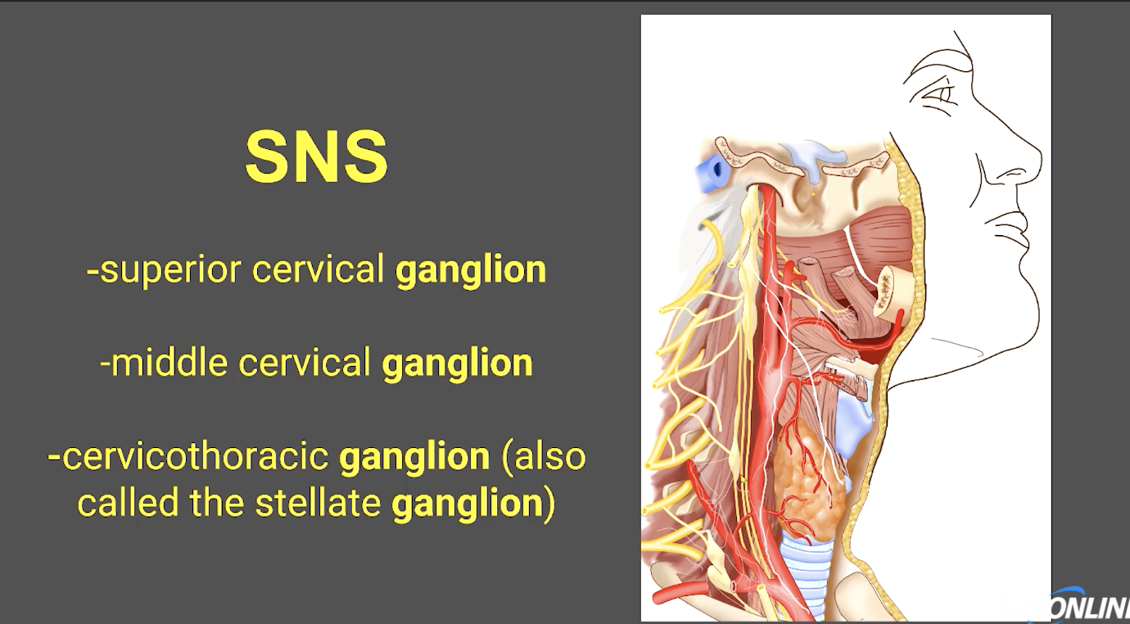

**LAYERS OF FASCIA FOMRING CAROTID SHEATH**

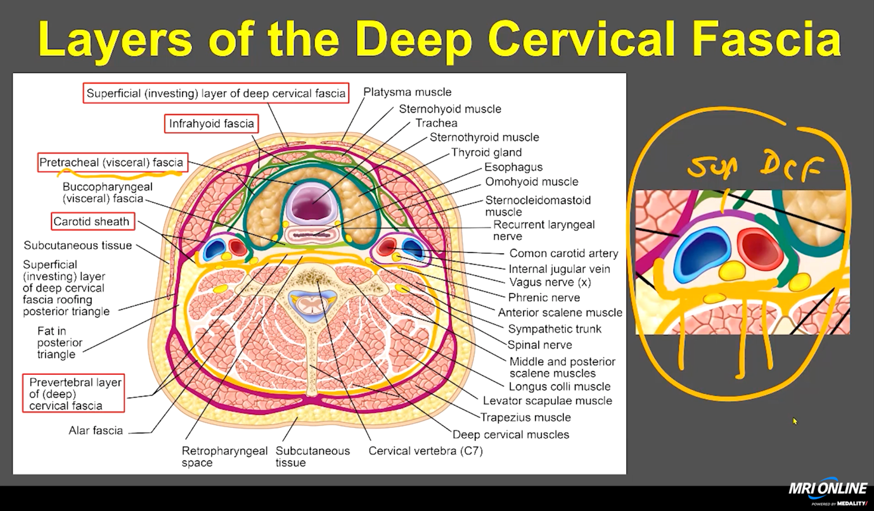

**Hypopharynx :**

**Has three parts :**

**Pyriform sinuses**

**Posterior pharyngeal wall (inferior constrictor muscle)**

**Post cricoid area- that is anterior mucosa directly behind the cricoid cartilage.**

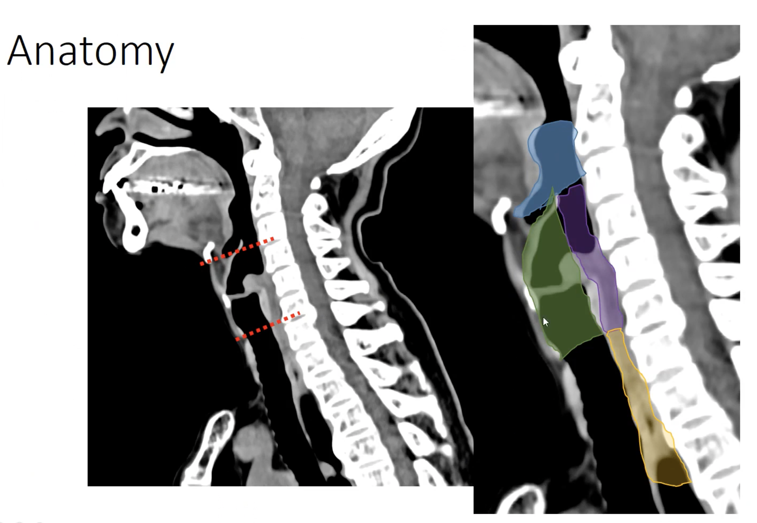

**Green: Larynx**

**Blue: oropharynx- starts from mid C2**

**Purple: Hypopharynx – starts from C3 t o C6 (cricoid)**

**Brown: Cervical oesophagus**

**Remember, vallecula is part of Oropharynx , not hypopharynx**

**Piriform sinus is the largest part of Hypopharynx- the contrast tend to stay there in barium swallow.**

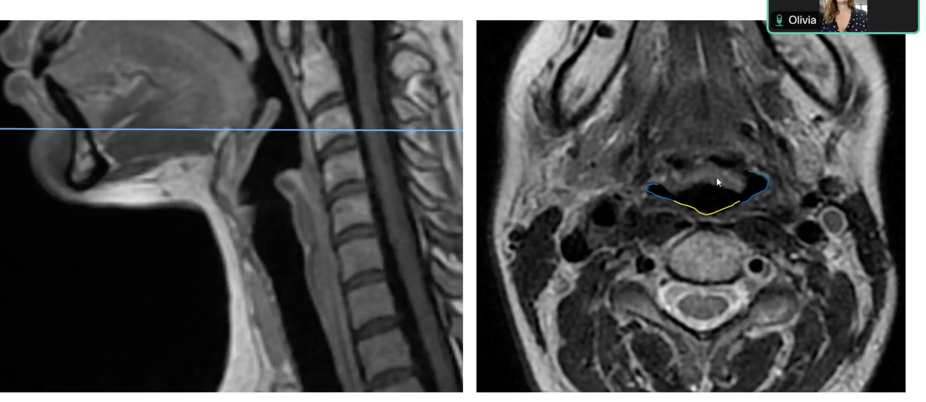

**NASOPHARYNX :**

The cartilaginous part of the Eustachian tube bulges into nasopharynx -this part is known as Torus Tubaris. The distal part of the tube shows rounded bulge which appears T2 hyperintense – it is normal and not a retention cyst.

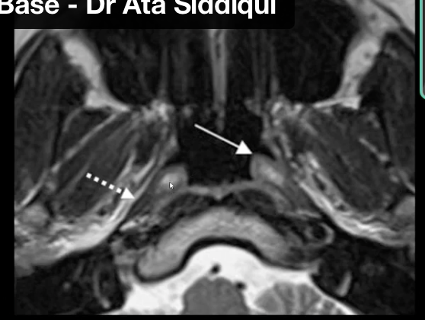







Levator Veli Palati



Tensor palati muscle



Levator veli palati muscle is part of nasopharynx. The tensor palati lies just lateral and is part of nasopharynx.

Lymphoid hyperplasia veruss lymphoma :

See image below:

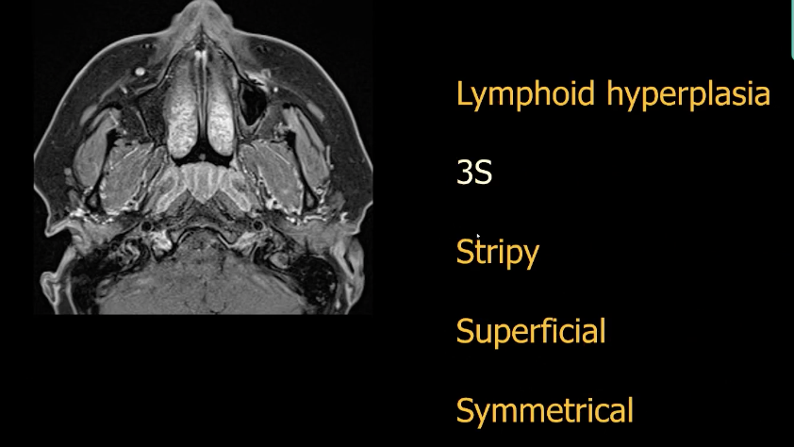

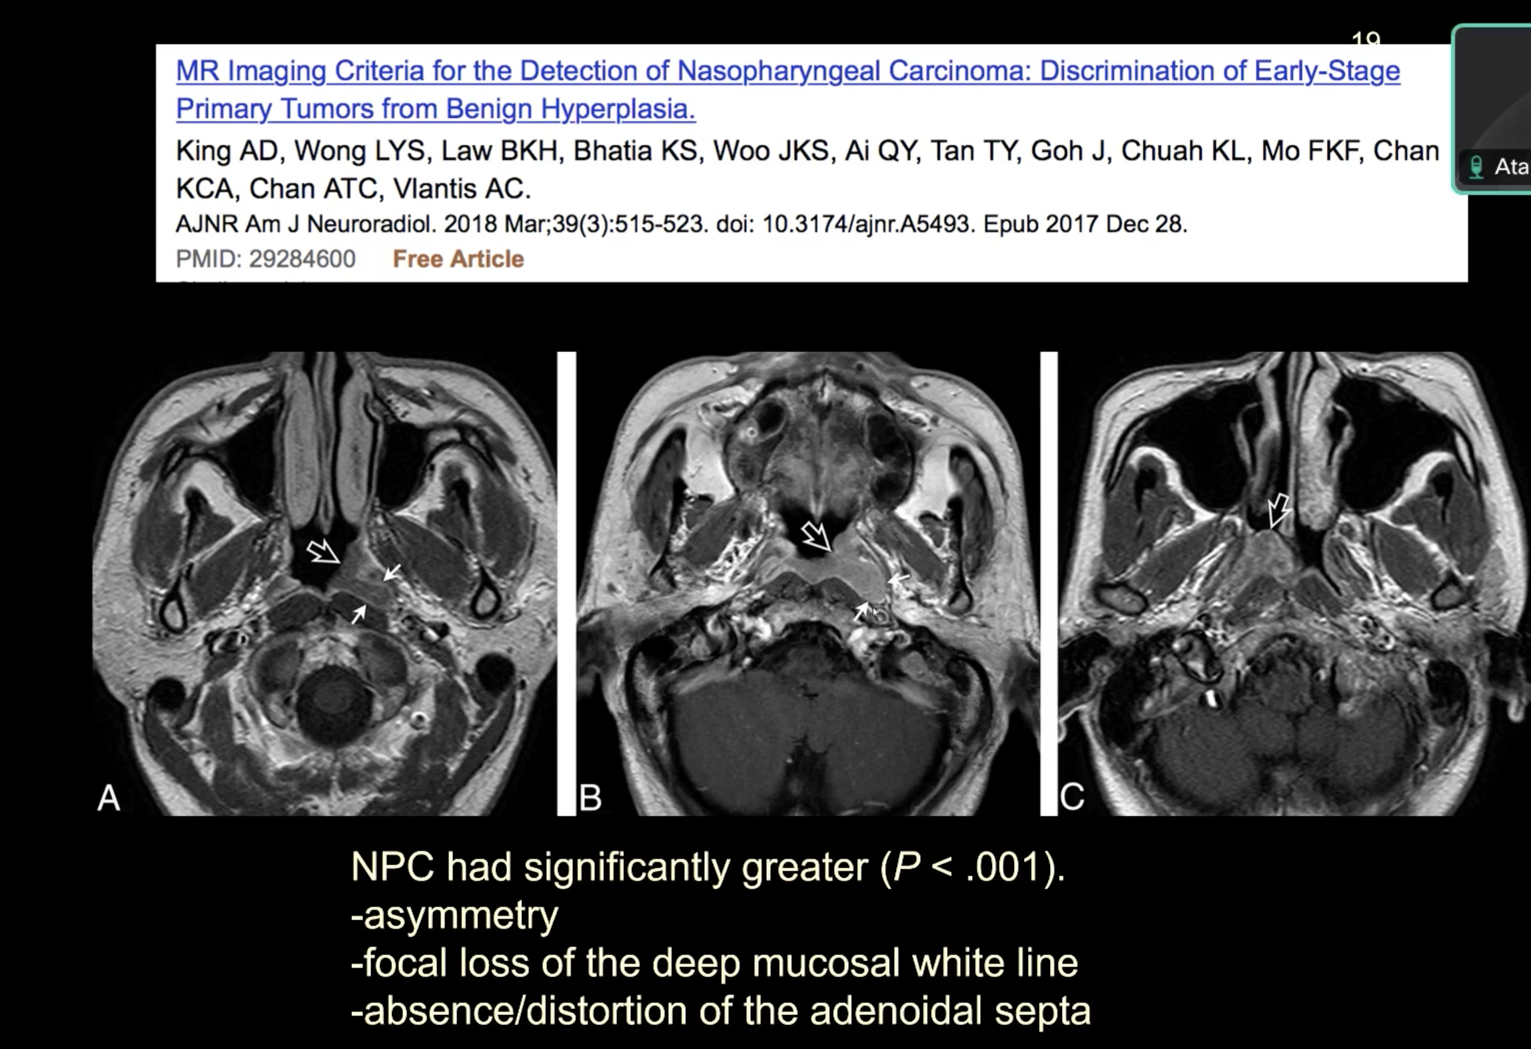

Nasopharyngeal cancer commonly present as nodal mets to Level 2B and Level 5 as well as retropharyngeal nodes.

Common cancer arising around nasopharynx are as follows :

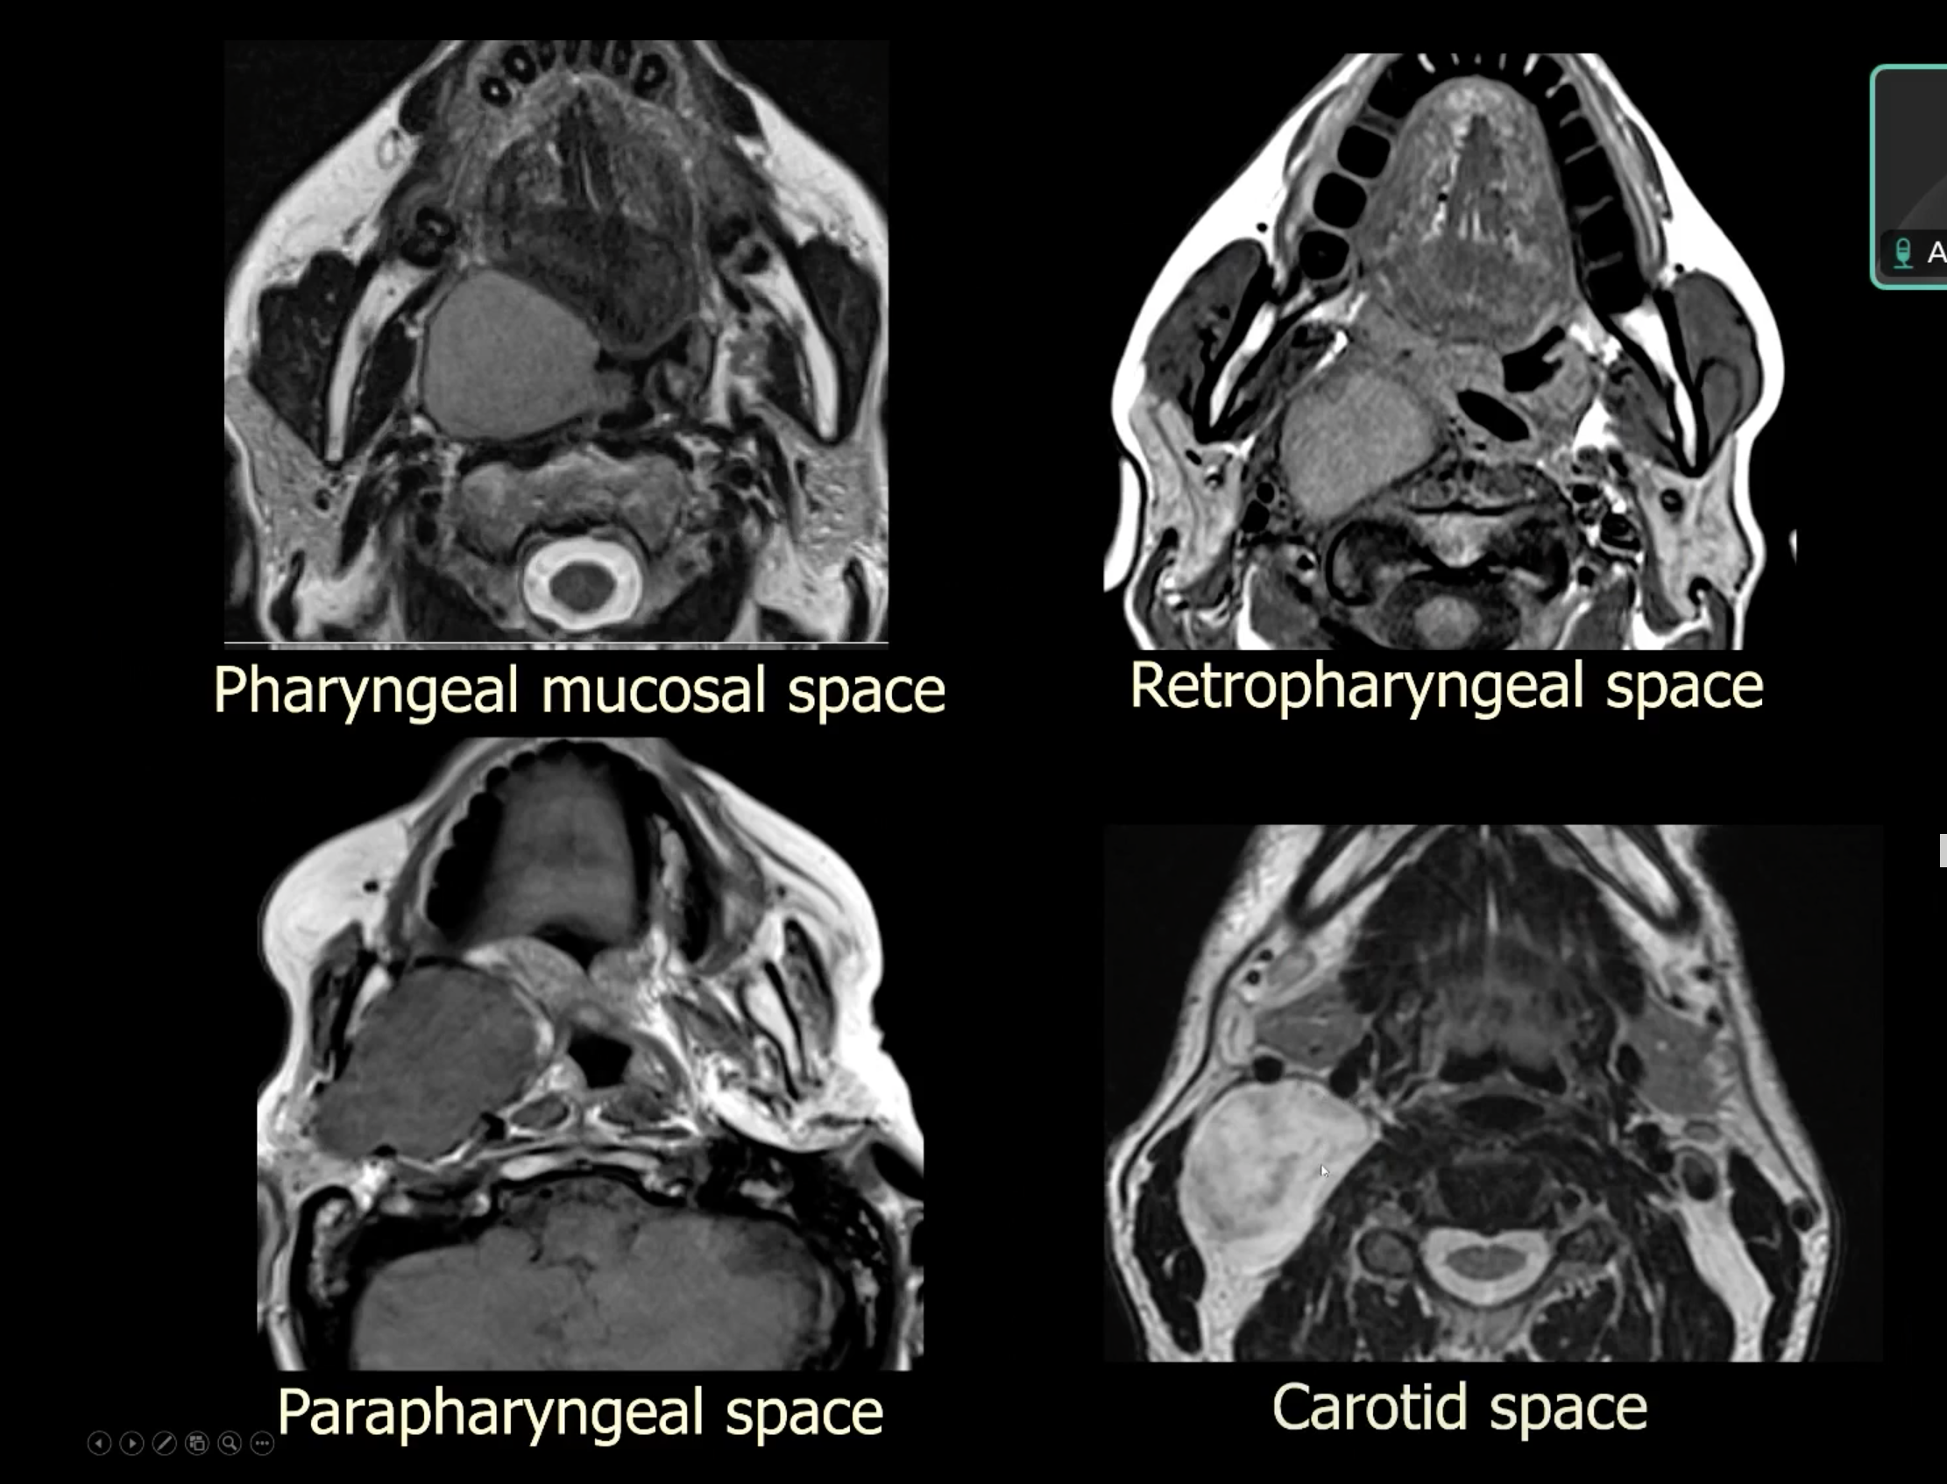

TNM staging of nasopharyngeal cancer:

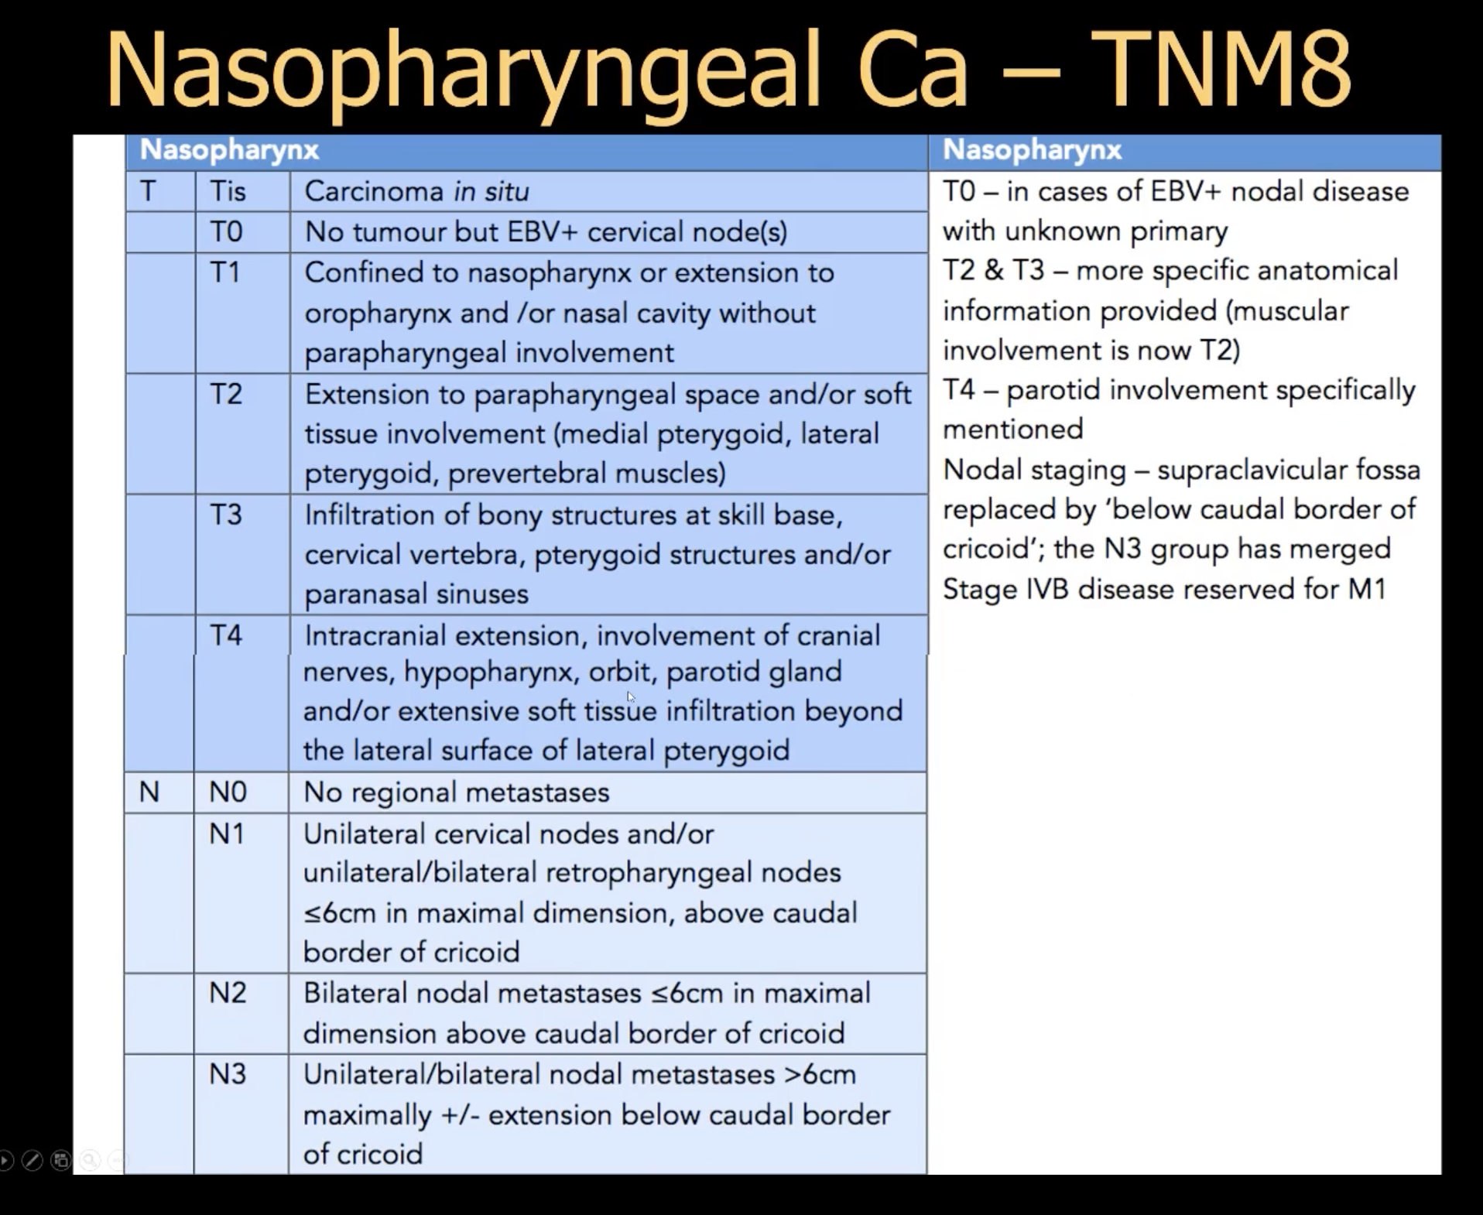

Tumour spreading from within the nasopharynx can spread via F. Lacerum as it lies just lateral to nasopharynx.

Tumour going to pterygopalatine fossa will involve **Foramina Rotundum** and V2 nerve (Maxillary nerve)- Rotundum stands for round – it is more medial foramina (compared to foramina ovale). Maxilla is more medial than mandible hence the foramina for maxillary nerve has to be more medial.

Further laterally, there is foramina for mandibular nerve(V3)- Formina Ovale (because it is oval in shape unlike foramina rotundum which is round in shape).

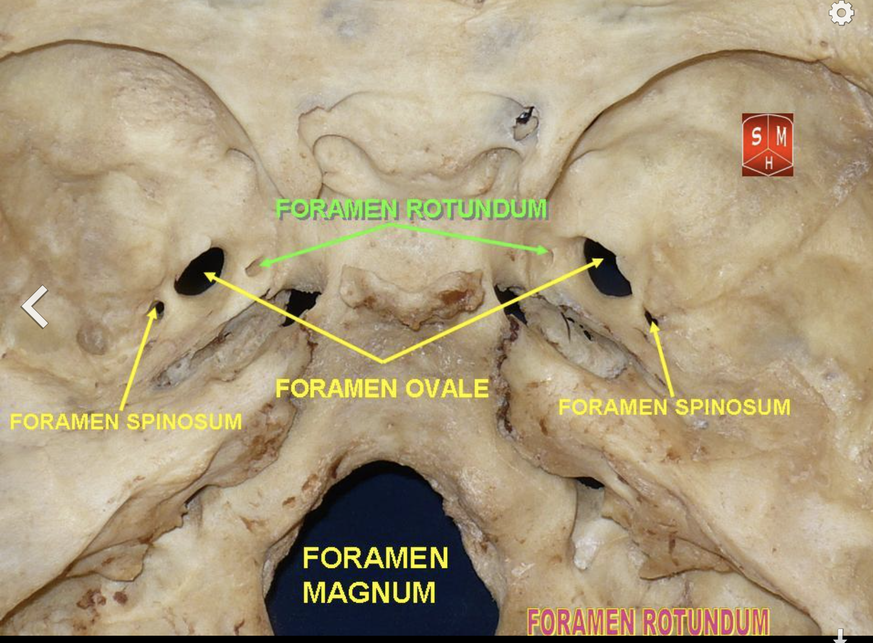

Staging investigations in nasopharyngeal tumours:

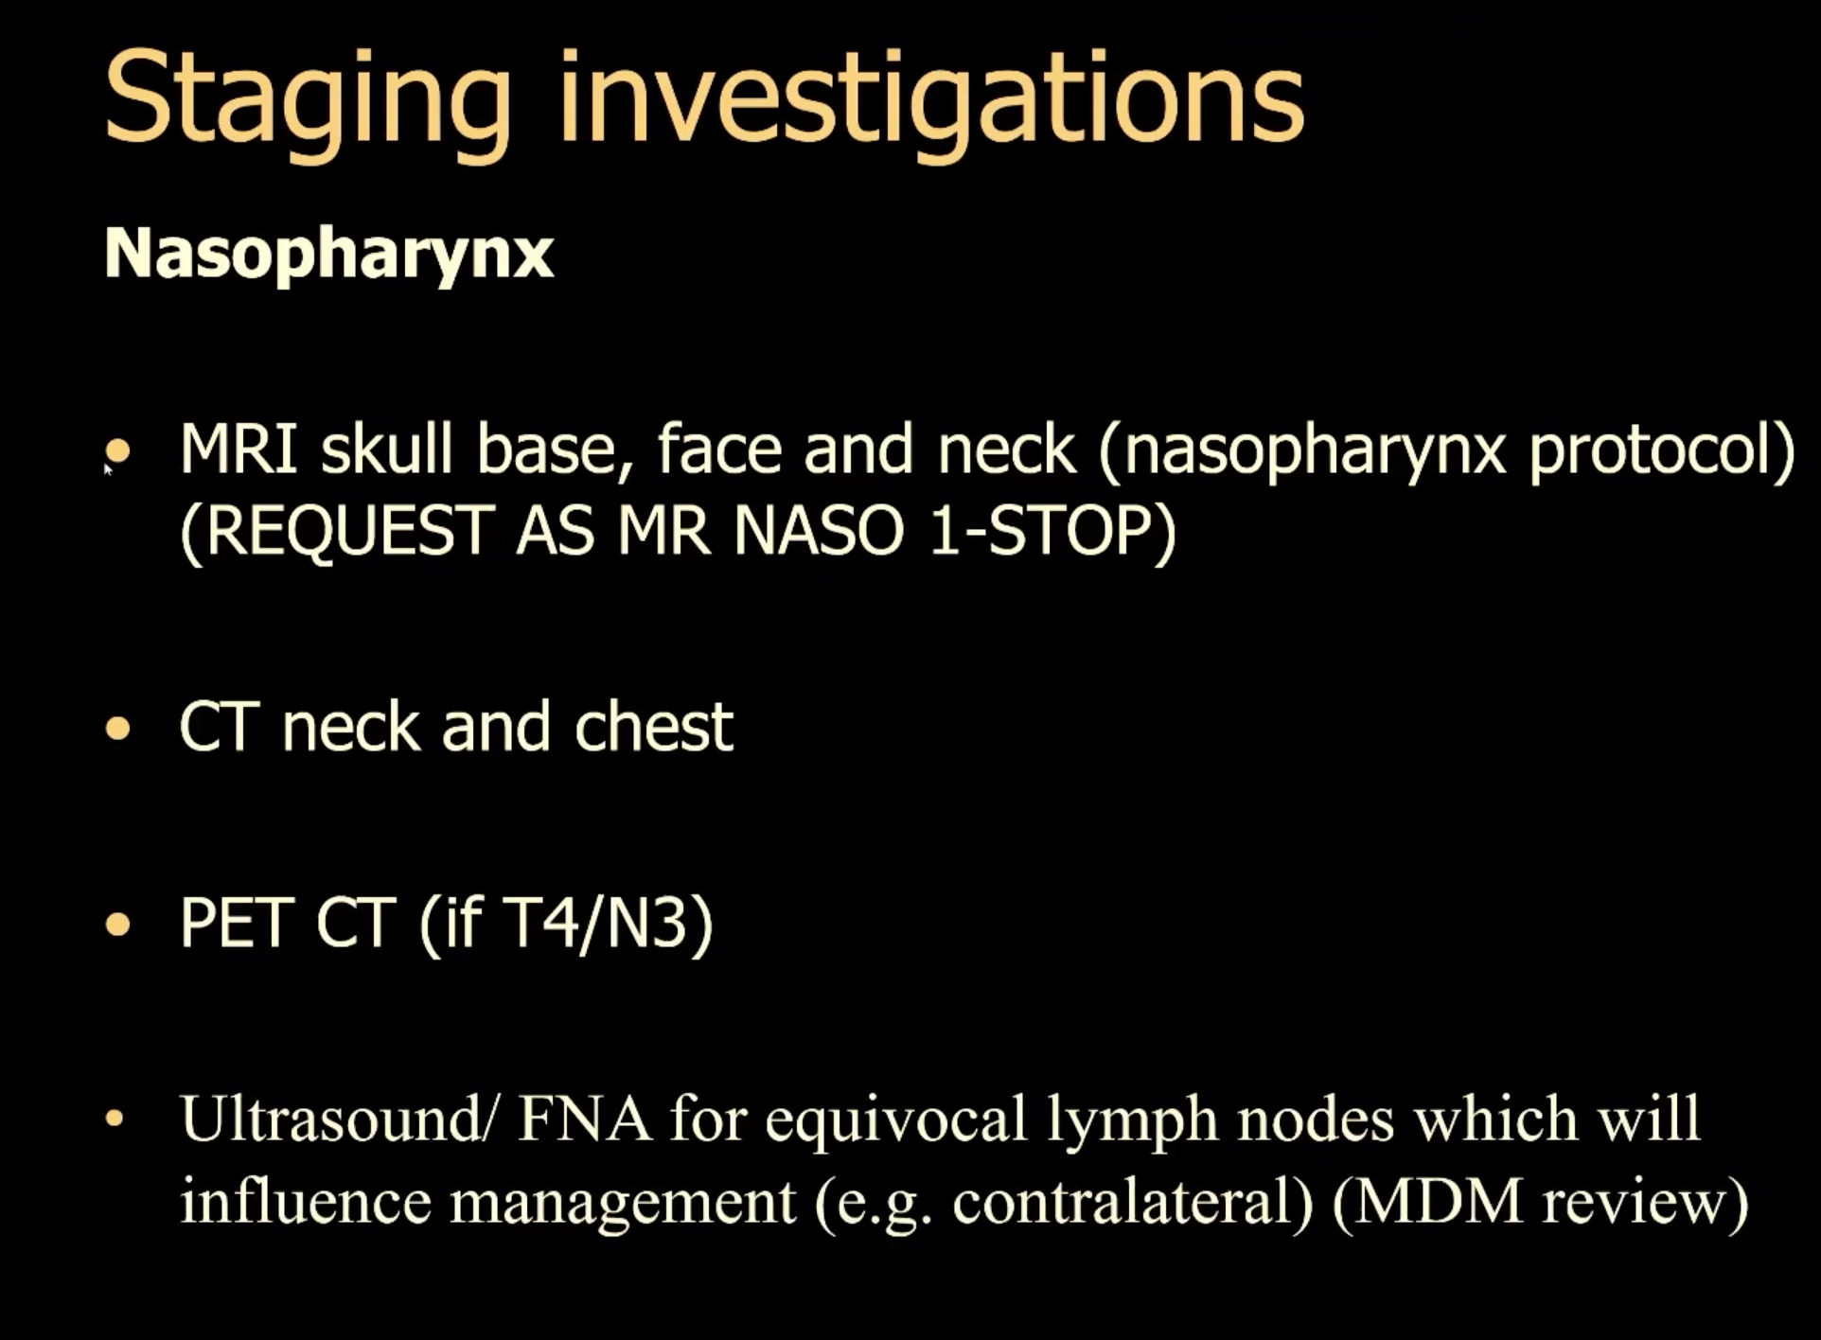

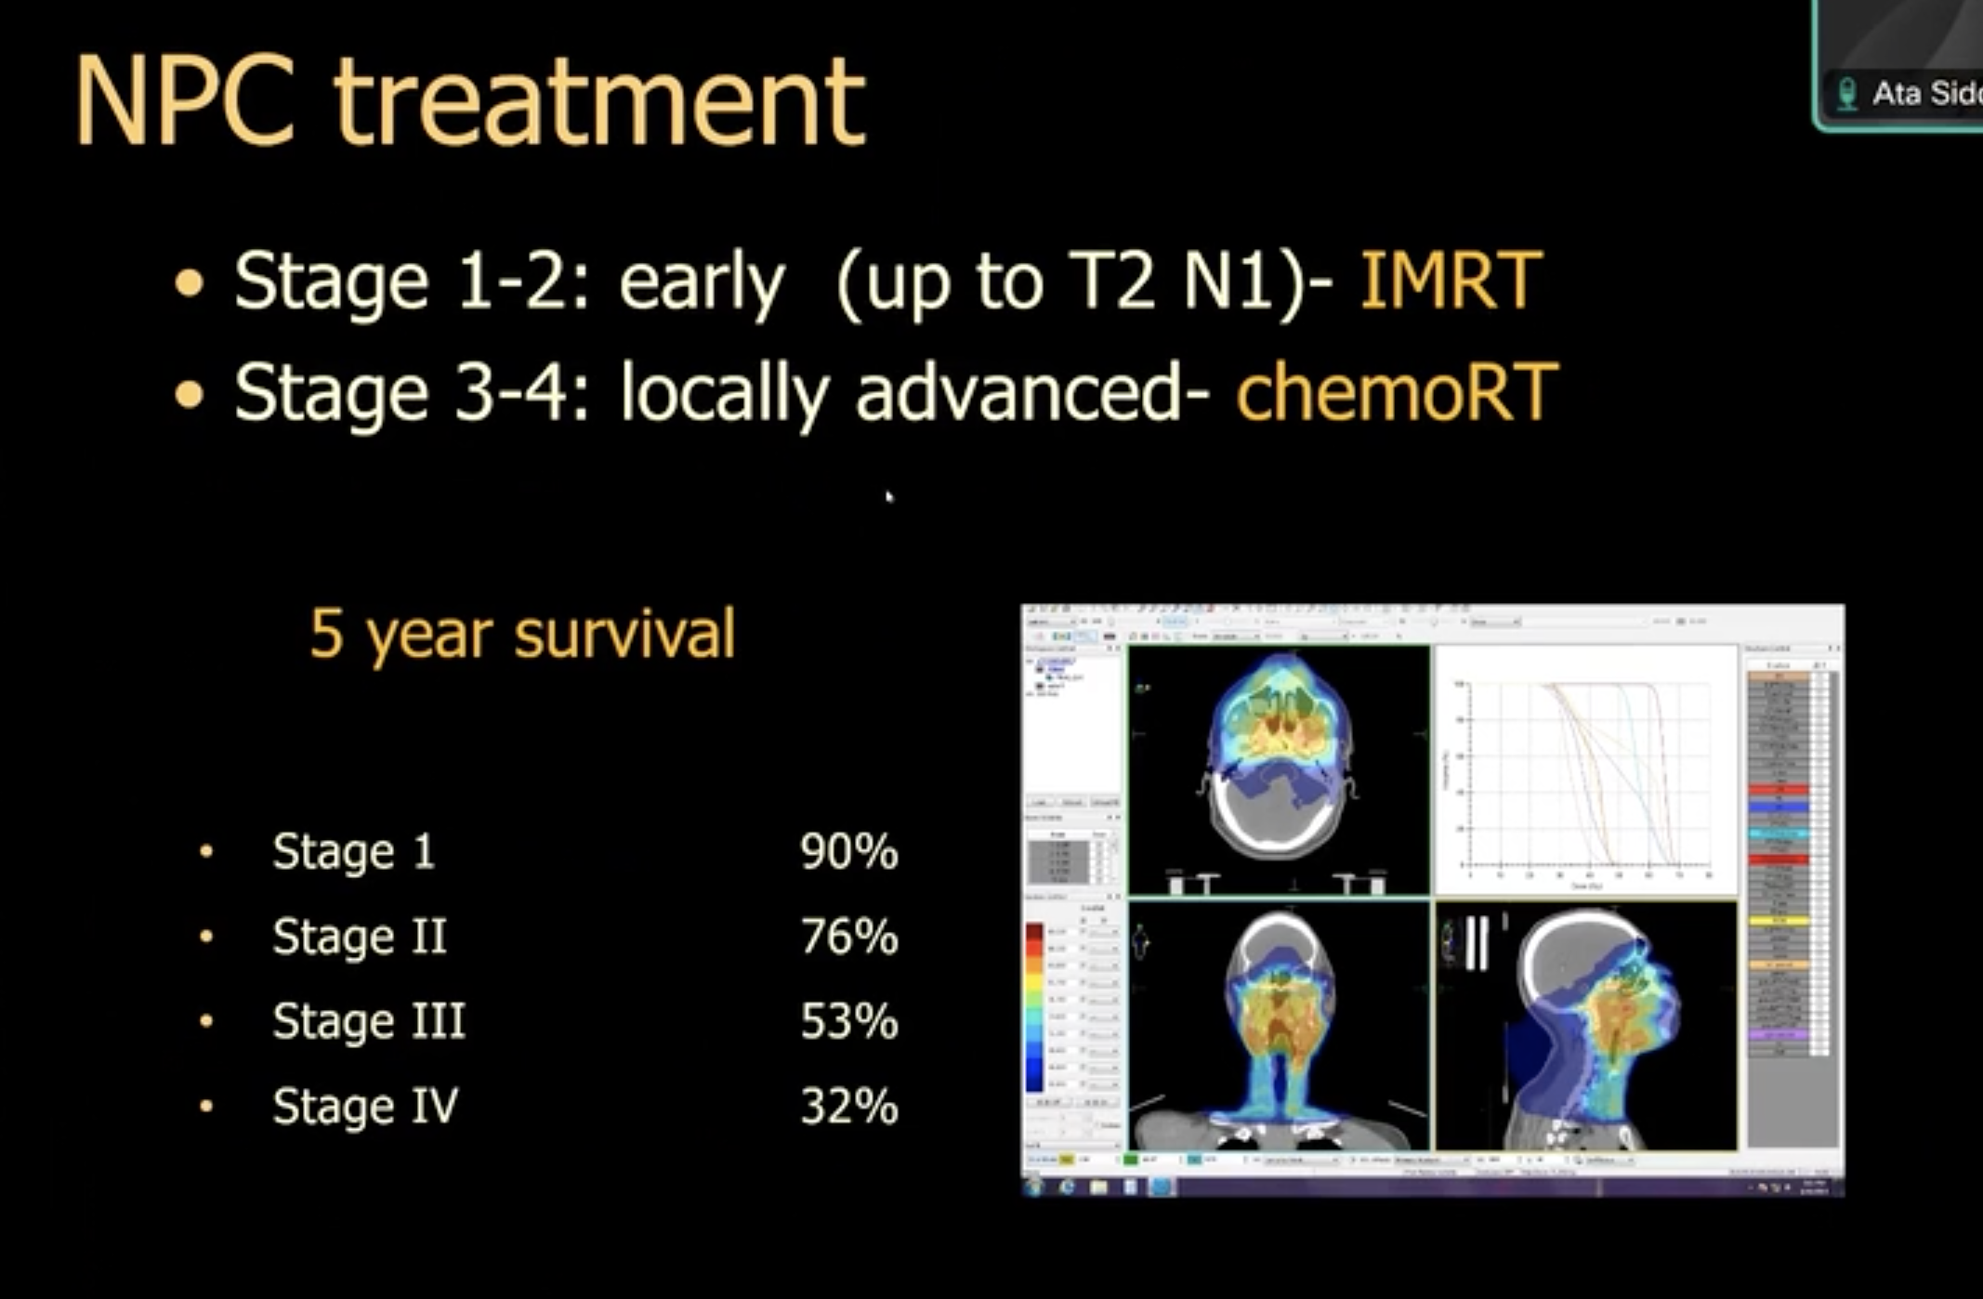

Remember, the VIth nerve lies within the cavity of cavernous sinus, as opposed to other cranial nerve which lie in the wall of the cavernous sinus. Therefore in tumours causing involvement of the cavernous sinus, one of the first nerve to get involved is VI nerve. Laos worth noting that VIth nerve has long course- it arising form pontomedullary junction then goes up to enter cavernous sinus after passing bony canal known as Dorell’s canal. There is very commonly involved in mass effects and hence also considered as false locating sign.

Keep in mind Osteo radionecrosis : 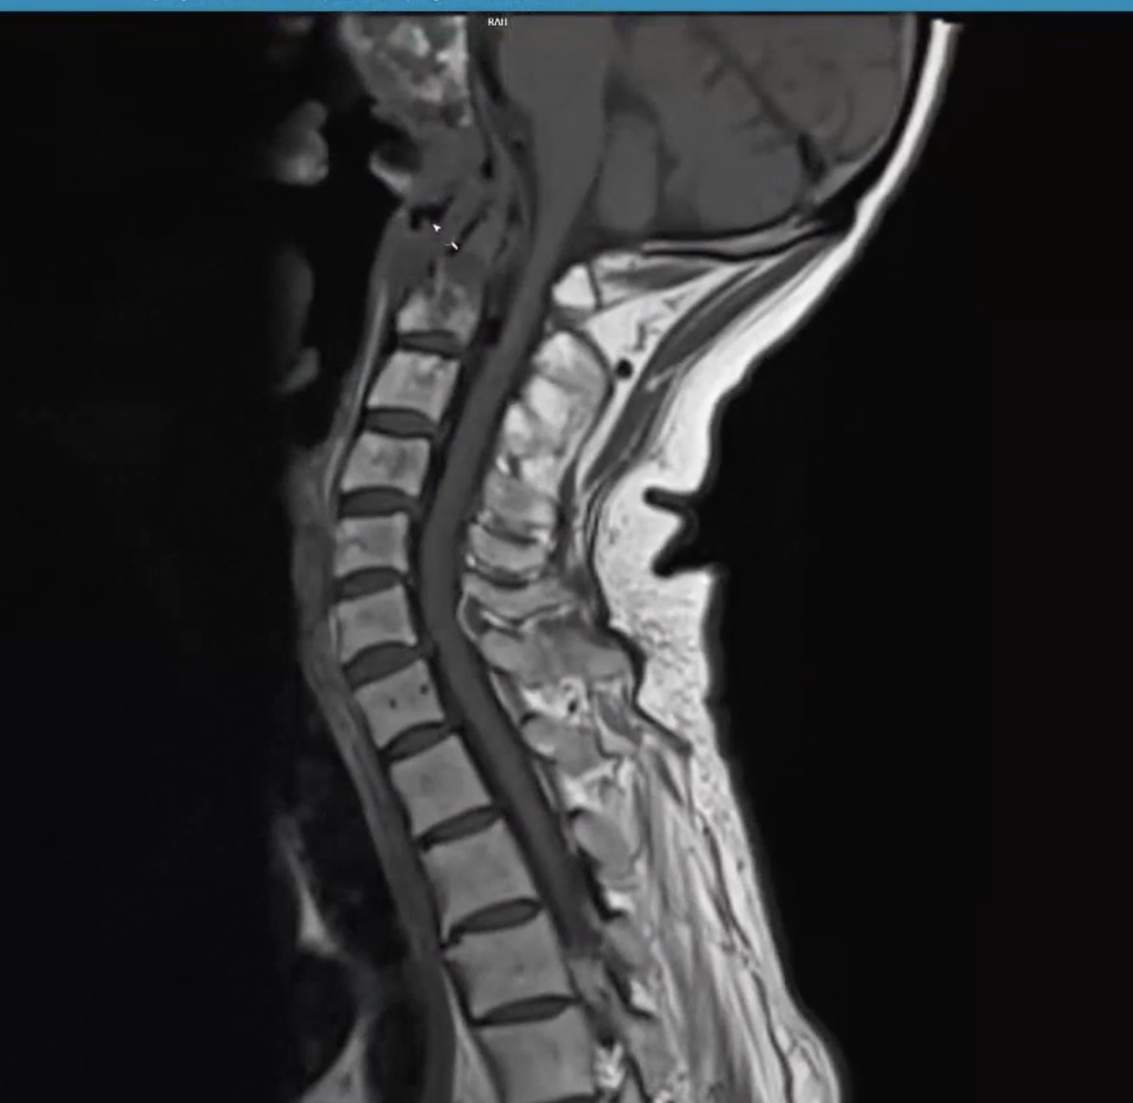

Treatment of the osteonecrosis is treating infection and try and debride the involved bones.

Post RT signal changes can last for long.

Another complication of radiation treatment is following (see image below):

Swiss cheese appearance of the brain and also bone involved. The involved brain do not enhance and is not PET avid and doesn’t restrict in diffusion.

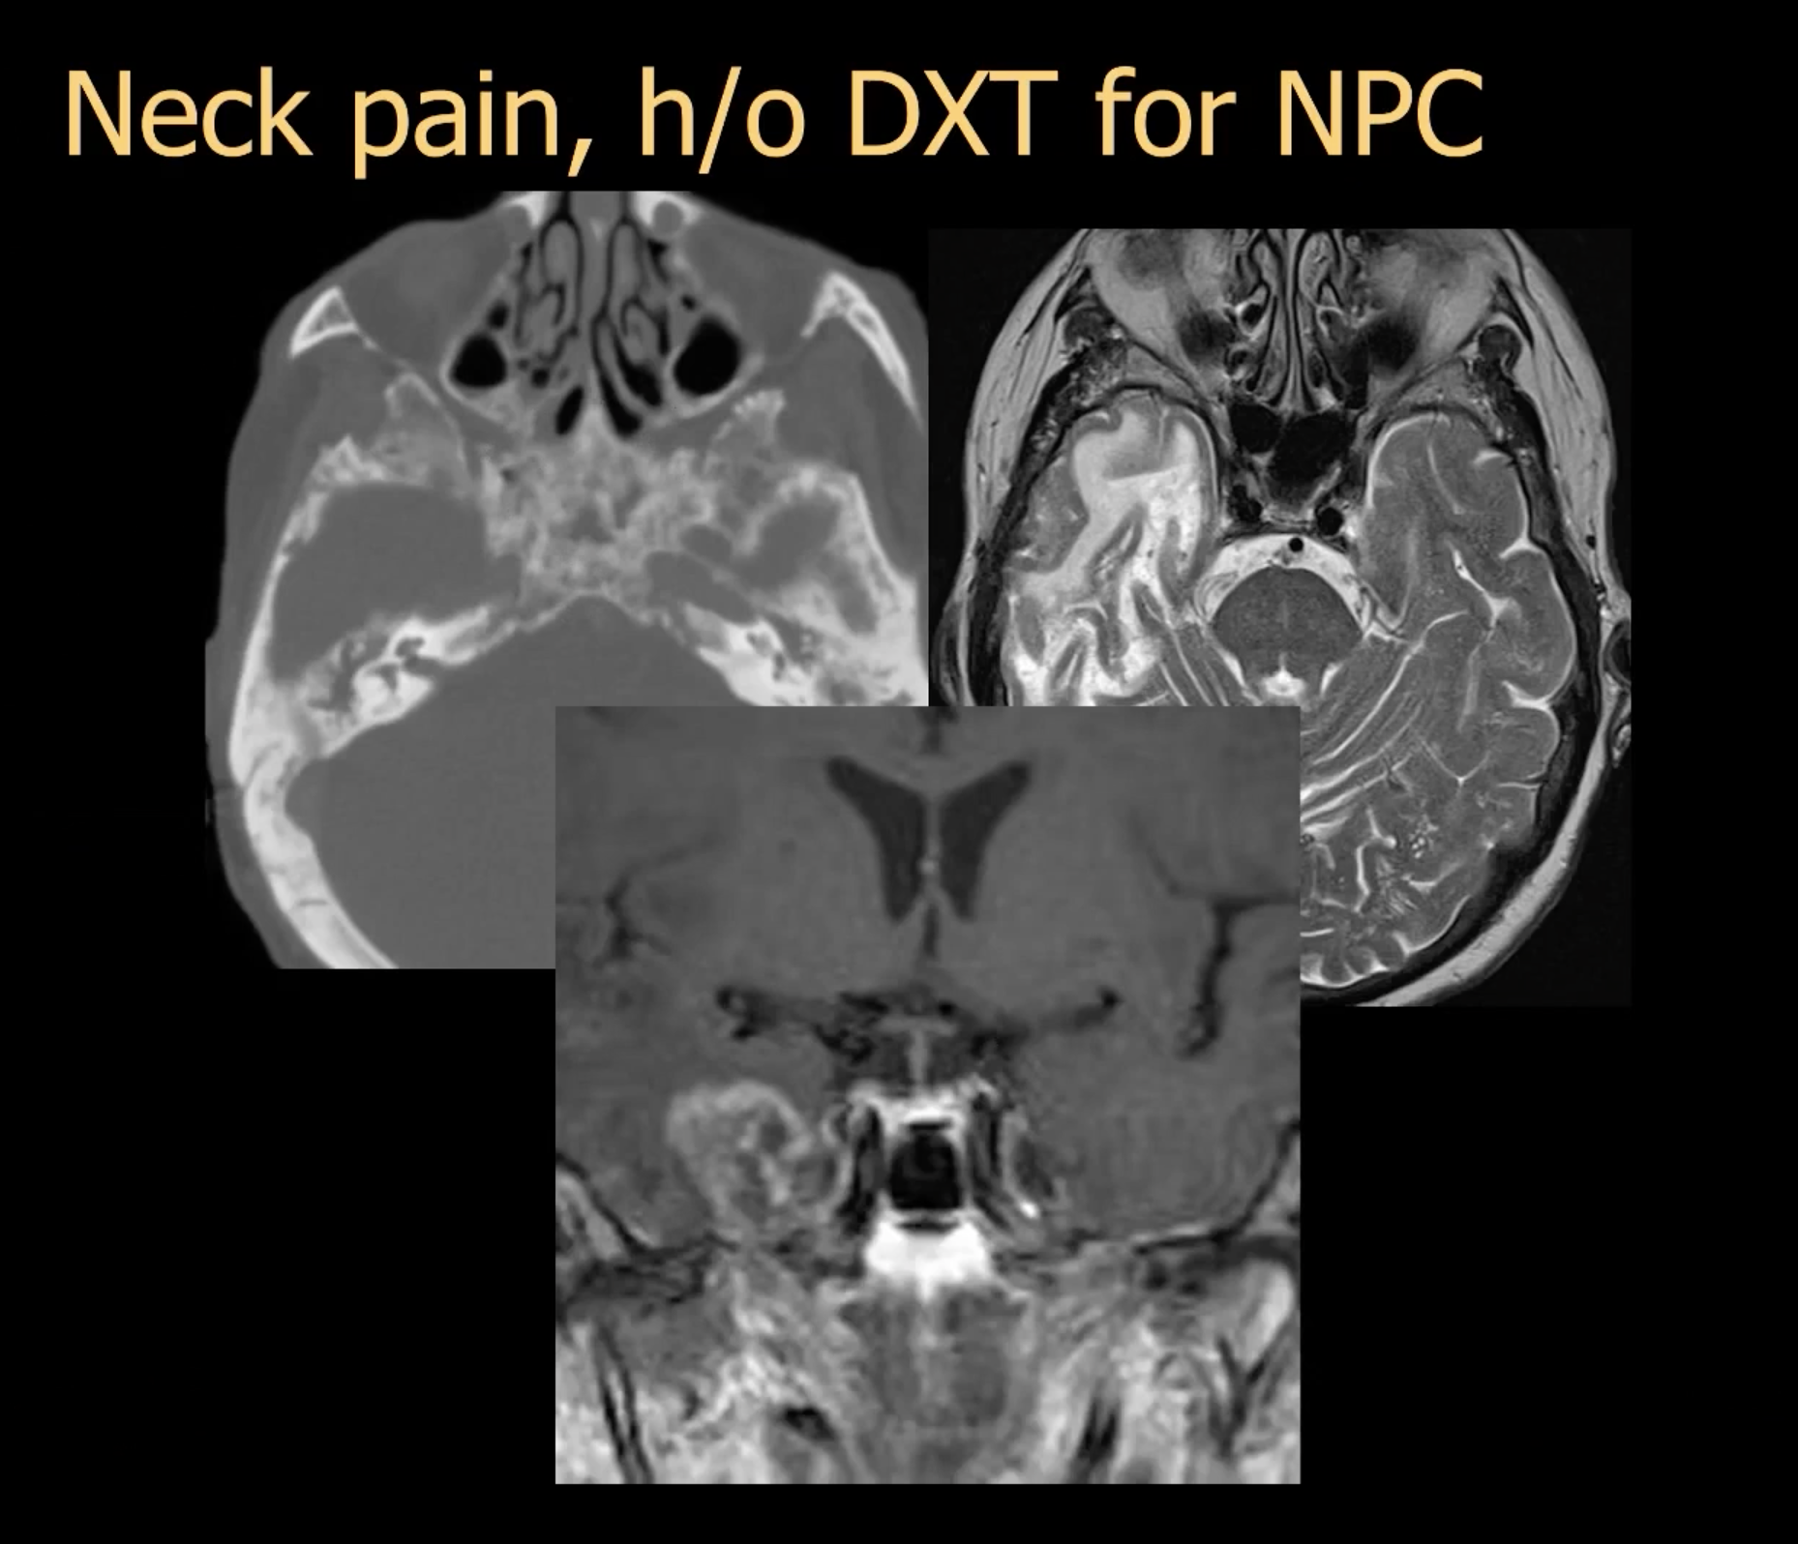

Another example of radition brain necrosis is below:

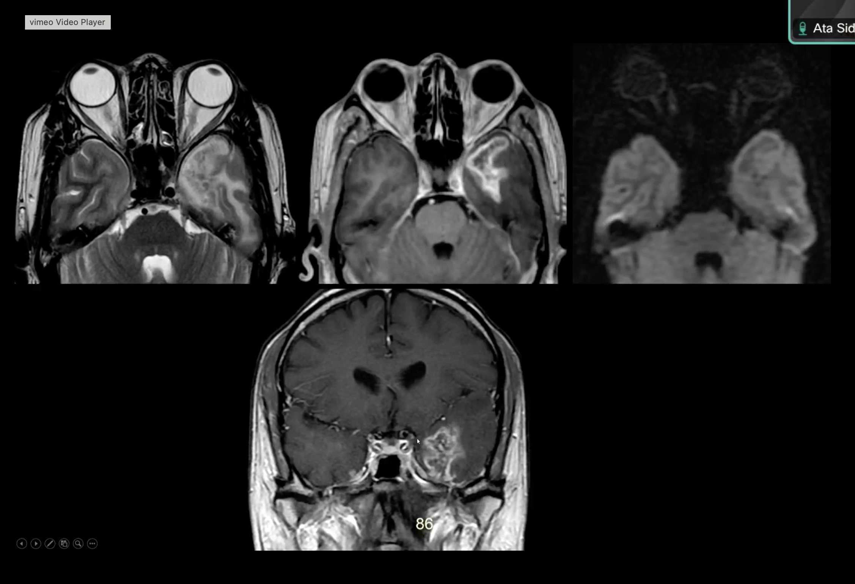

Skull base Chordoma versus Chondrosarcoma :

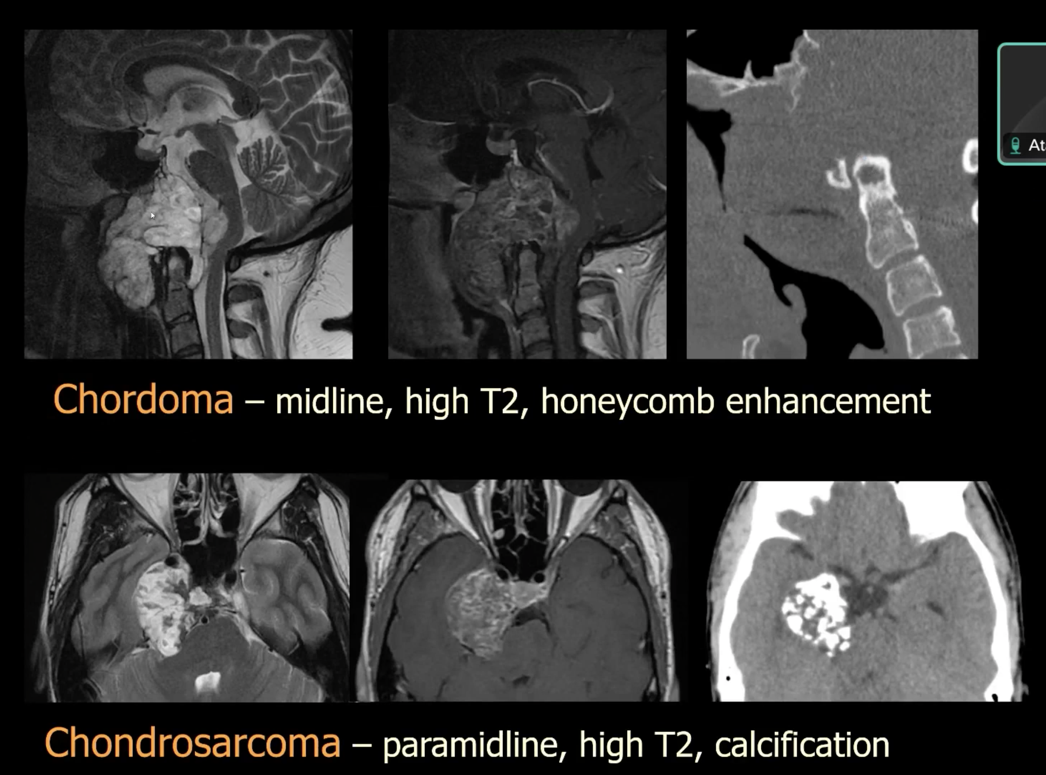

Benign lesion of clivus is : Echordosis Phyali[phora

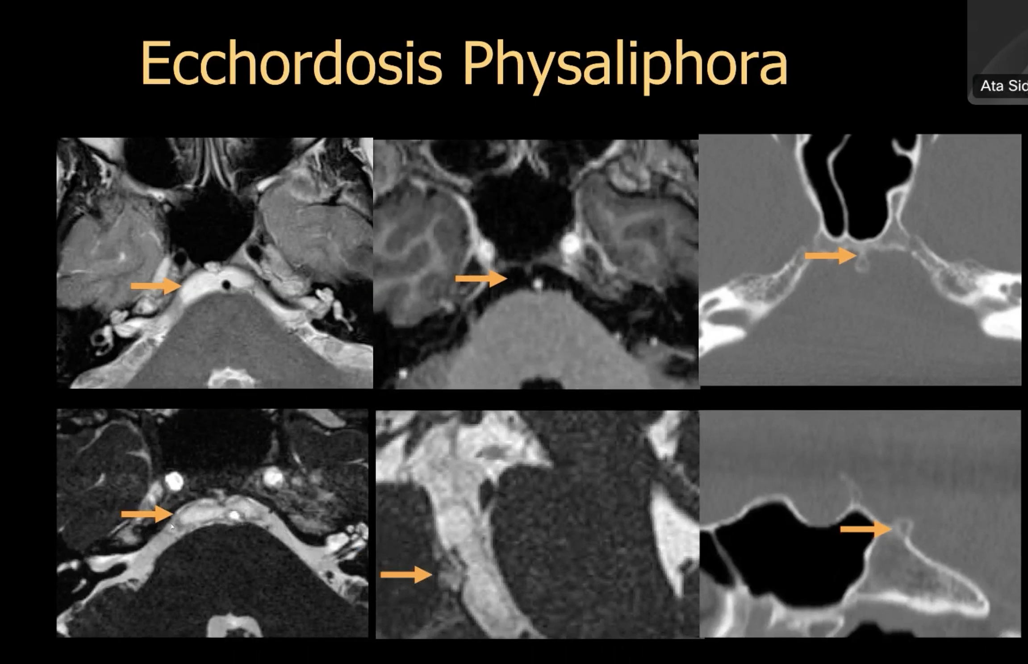

Other notochord remmants are :

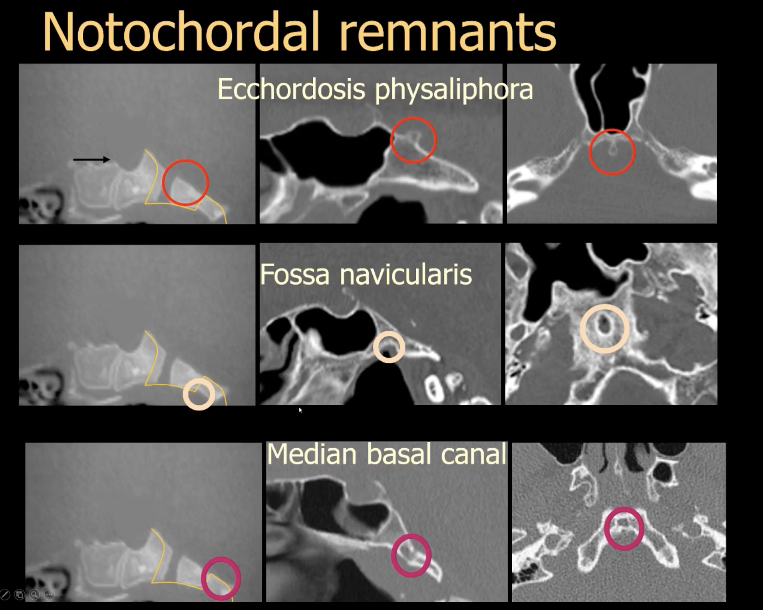

AT LEAST one follow up is recommended for ensure that these are not tunour.

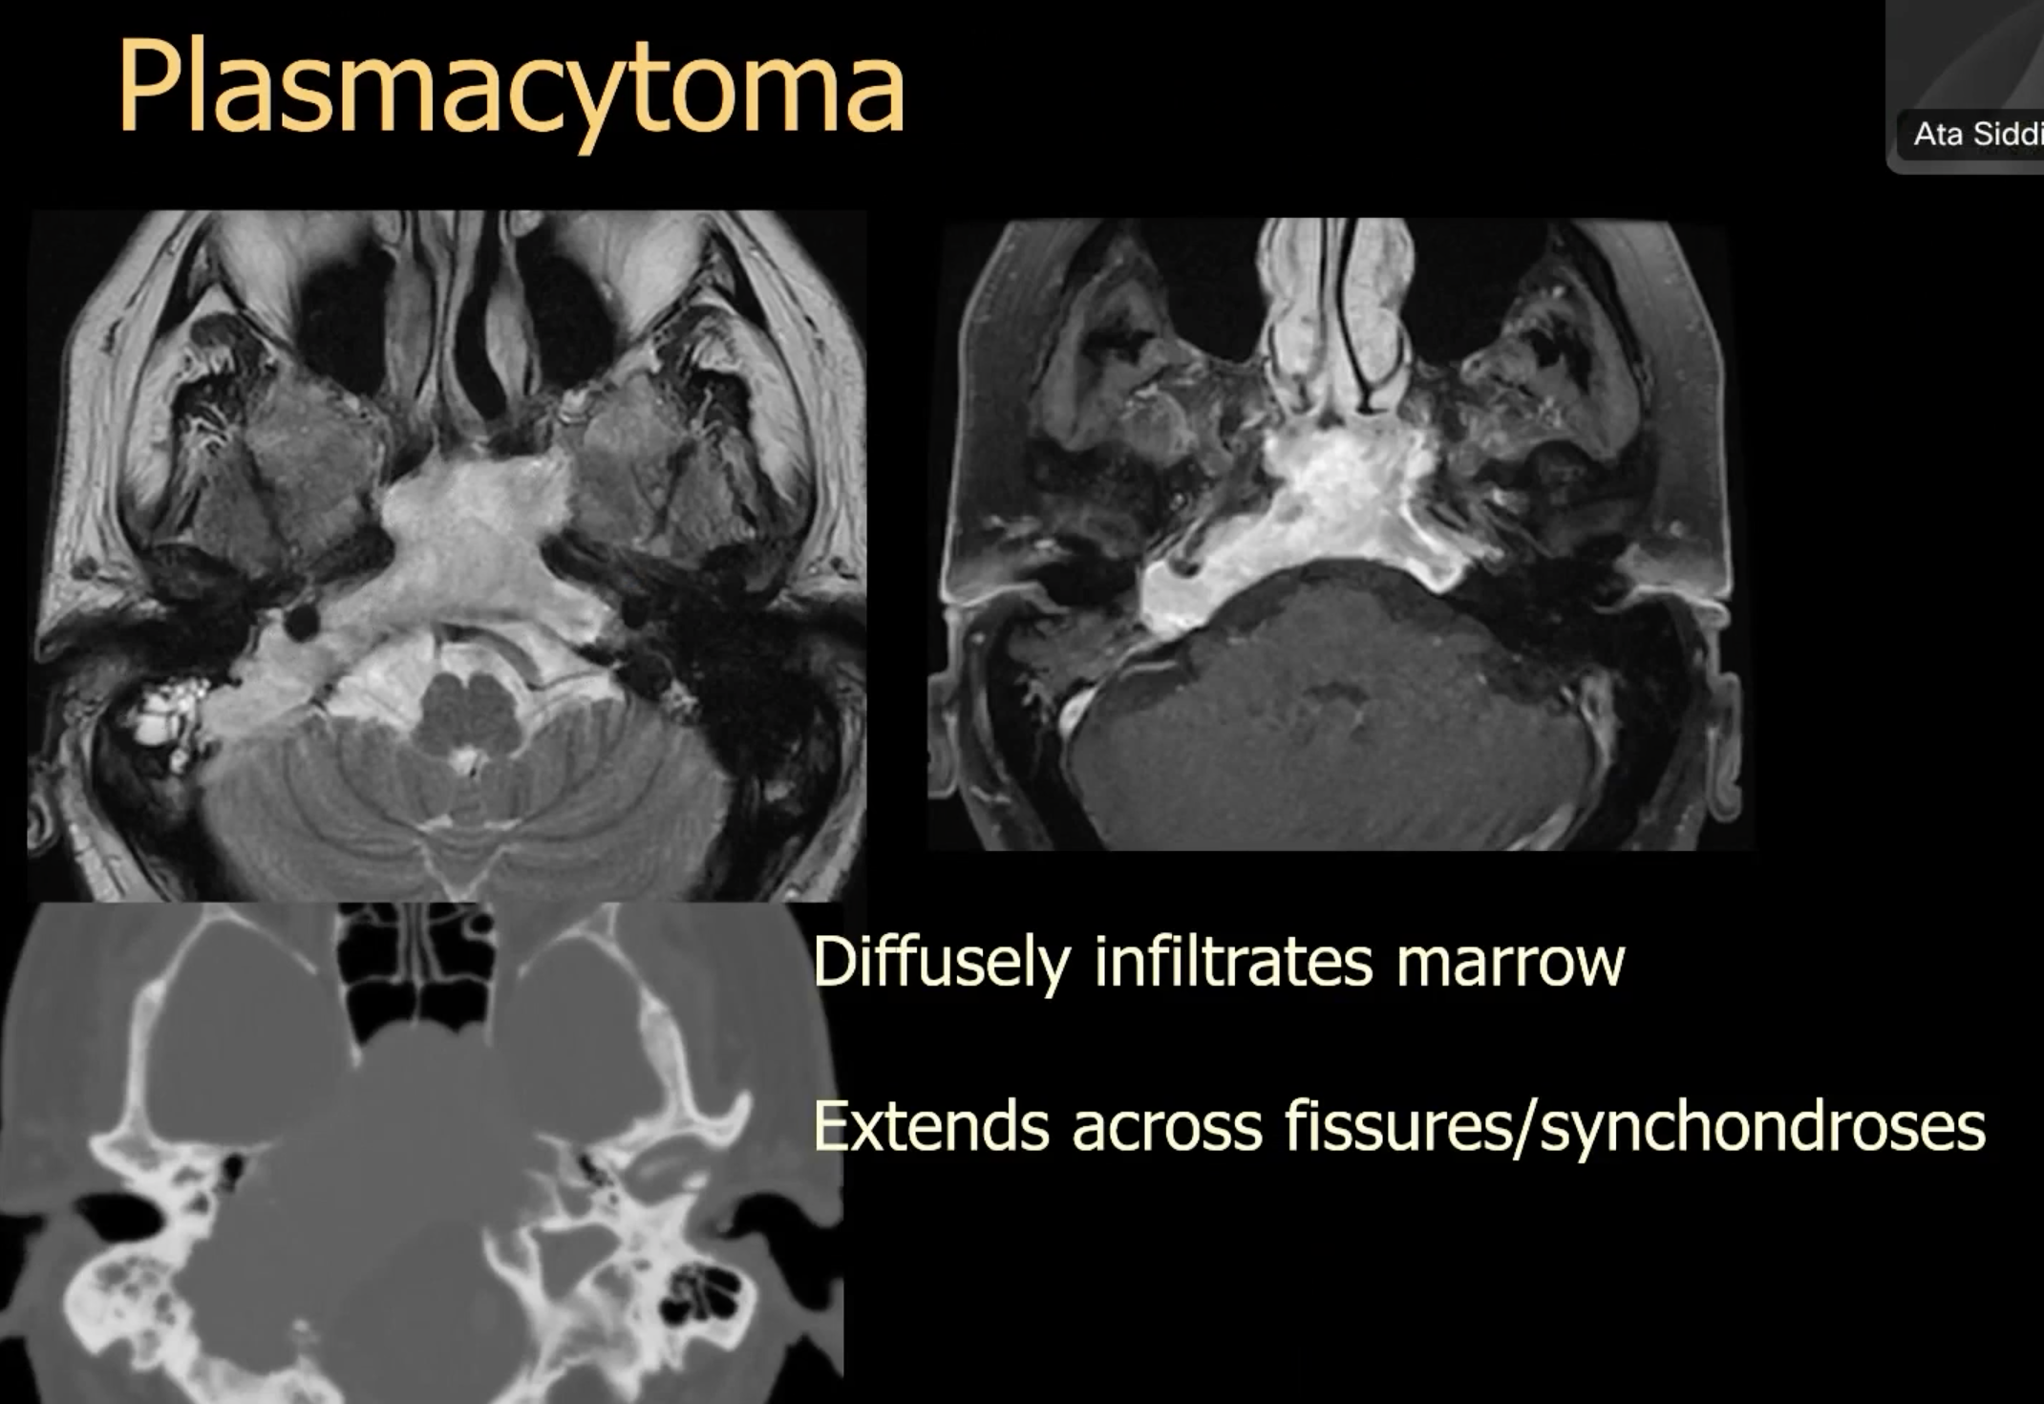

Below is an example of a lesion seen in newborns: known as hairy polyp:

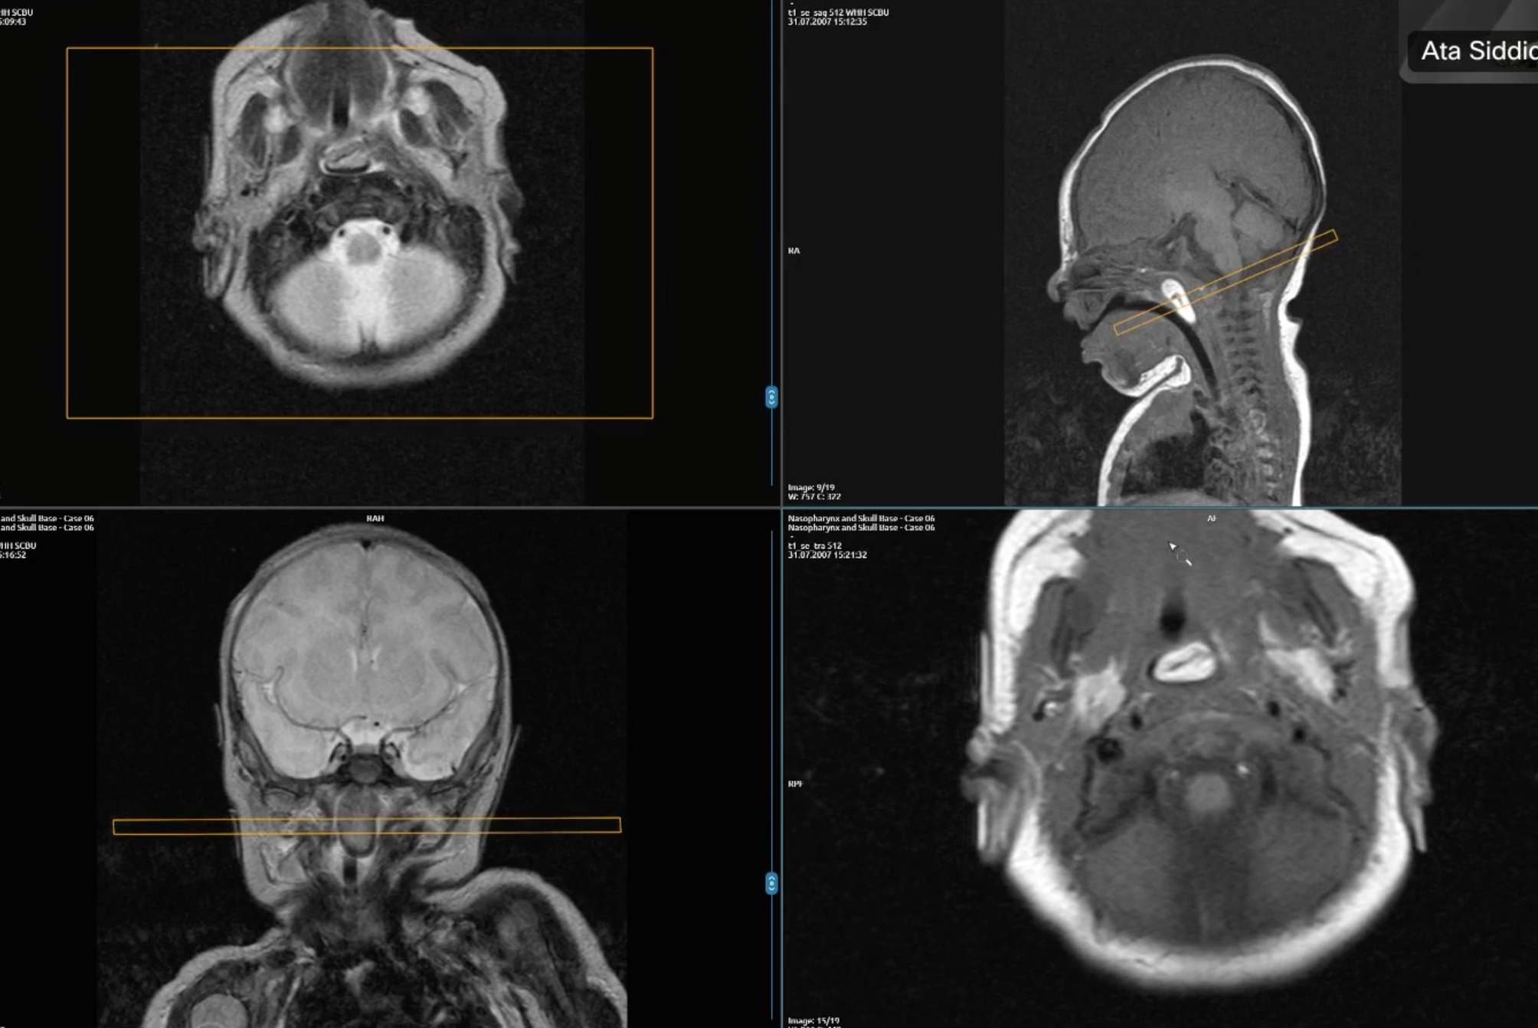

JNA arise from sphenopaltine foramina.

Unlike RMS and other aggressive tumour , JNA do not restrict much in DWI.

